Tuvalu
Energy Sector Development Project – Solar Array
Environmental and Social Management Plan

Tuvalu Energy Sector Development Project (ESDP) – Solar PV Array
Environmental and Social Management Plan

Quality Information
Document | Energy Sector Development Project (ESDP) Solar Array Environmental and Social Management Plan Revision D
Date | 01 February2024
Prepared by | Tuvalu Central Project Management Office (CPMO)

Revision History
Revision | Revision Date | Details
A | 17 Dec 2018 | Draft for Stakeholder Review
B | 11 June 2019 | Revised for changed installation location and WB Rev A review comments
C | 02 Feb 2023 | Updated based on new design and location
D | 01 Feb 2024 | Updated based on WB comments to Version C

Acronyms and Abbreviations

AP | Affected Persons
BESS | Battery Energy Storage System
CoP | Code of Practice
EE | Energy Efficiency
EPA | Environmental Protection Act
ESDP | Energy Sector Development Project
ESMF | Environmental and Social Management Framework
ESMP | Environmental and Social Management Plan
FNLTB | Funafuti Native Lands Trust Board
GBV | Gender Based Violence
GoT | Government of Tuvalu
GRM | Grievance Redress Mechanism
IDA | International Development Association
MESC | Ministry of Education, Sports and Culture
MoF | Ministry of Finance
MOA | Memorandum of Agreement
NGO | Non-Governmental Organisation
O&M | Operation and Maintenance
OHS | Operational Health and Safety
PCR | Physical Cultural Resources
PEAR | Preliminary Environmental Assessment Report
PIB | Public Information Brochure
PIU | Project Implementation Unit
PSC | Project Steering Committee
PV | Photovoltaic
RAP | Resettlement Action Plan
RE | Renewable Energy
RPF | Resettlement Policy Framework
SOP | Standard Operating Procedures
SPE | Secretariat for the Pacific Community
SWMP | Solid Waste Management Plan
TEC | Tuvalu Electricity Corporation
TMP | Traffic Management Plan
TNEP | Tuvalu National Energy Policy
TT | Task Team
TvAIP | Tuvalu Aviation Investment Project
WB | World Bank
WMD | Waste Management Department

Contents
1 Introduction 5
1.1 ESMP Purpose and Scope 5
1.2 Integration of ESMP 6
1.3 Disclosure 6
2 Project Description 7
2.1 Overview of Works 7
2.2 Project Sites 8
2.2.1 Solar PV Sites 8
2.2.2 Battery Energy Storage Site 15
2.3 Ancillary Project Components 17
2.4 Land Acquisition 19
3 Environmental and Social Context 20
3.1 Land Use 20
3.2 Terrestrial Environment 20
3.3 Marine Environment 21
3.4 Climate Change Threats 22
3.5 Waste Management 22
4 Environmental and Social Risk Management Legislation and Policy 23
4.1 Tuvalu Environment Protection Act 2008 and 2014 EIA Regulations 23
4.1.1 EIA Regulations 2014 23
4.1.2 Schedule 1 of the Environment Protection Act 2006 23
4.2 World Bank Safeguard Policies 24
4.2.1 OP/BP4.01 Environmental Assessment 24
4.2.2 OP/BP4.12 Involuntary Resettlement 24
4.2.3 Other Safeguard Policies 24
4.2.4 Gender Action Plan 25
5 Impacts and Mitigation Plan 25
5.1 Key Identified Impacts 26
5.1.1 Environmental Impacts During Construction Phase 26
5.1.2 Social Impacts During Construction Phase 29
5.2 Mitigation Tables 30
Solar PV Installation Design and Pre-Construction Phase Management Plan 30
Solar PV Installation Construction Phase Mitigation Plan 35
Solar PV Installation Operational Phase Mitigation Plan 40
6 Monitoring Plan 42
7 Consultations 46
7.1 Communication Plan 46
7.2 Consultation Guidelines 47
7.3 Grievance Redress Management 48
8 Institutional Arrangements 49
8.1 Roles and Responsibilities 49
8.1.1 Safeguards Specialist and Project Implementation Unit under TEC 49
8.1.2 Contractors 50
8.2 Monitoring, Evaluation and Reporting 50
9 Institutional Strengthening 52
9.1 Training 52
9.2 Budget 52
Appendix A: Workers Code of Conduct 53
Appendix B: Solid Waste Management Plan Requirements 56

Introduction
This Environmental and Social Management Plan (ESMP) for the Energy Sector Development Project (ESDP) in Tuvalu, specifically addresses the solar PV array installation and Battery Energy Storage System (BESS) in Funafuti. The ESMP outlines mitigations, monitoring, and institutional measures to integrate environmental and social stewardship into the project, ensuring compliance with Tuvalu's laws, regulations, and the World Bank's Environmental and Social Safeguards Policies. It covers the design, implementation, and operation phases of the ESDP, aiming to eliminate, offset, or reduce adverse environmental and social impacts to acceptable levels.
Within Tuvalu, the major issues that the power sector currently faces include (a) high dependency on costly imported fuels; (b) the Tuvalu Electricity Corporation’s (TEC) insufficient revenues from tariffs to meet operating and maintenance (O&M) costs; (c) the high maintenance cost of generation and distribution systems in a marine environment; and (d) the need for capital to finance the power infrastructure requirements of Funafuti and the outer islands.
Tuvalu is addressing these issues through the formulation of a long-term energy policy and a master plan for implementing the policy targets. The 2009 Tuvalu National Energy Policy (TNEP) highlights a target of 100% renewable energy (RE) by 2020. In order to help Tuvalu achieve this target, New Zealand and other donors have various activities already underway. Most of these activities are focused on the replacement of diesel generation with RE technologies. In support of the Government of Tuvalu’s (GoT’s) goals in the energy sector the World Bank (WB) effort will provide additional energy generation from solar PV and BESS through ESDP.
The Solar PV project in Funafuti will have a 750kW grid-connected Solar PV facility and a 1MW/MWh BESS to ensure grid stability through sufficient battery storage and equipment that stabilizes the power supply. The project incurred cost overruns due to the COVID-19 pandemic, but it has received an additional $USD 6 million in financing from the World Bank to cover these expenses. The scope of work includes the design, engineering, planning, procurement, installation, testing, commissioning, and two years of O&M support.

ESMP Purpose and Scope
Environmental and social risk screening for the Solar PV array installation and BESS subprojects was based on field investigations, stakeholder consultation and a review of potential options confirms an assessment of Category B for the Project. It finds that potential impacts are less than significant, site specific, mostly reversible and that a range of potential measures for mitigation can be readily designed in the majority of cases.
Subproject screening has identified that the solar array installation requires an ESMP as per the process outlined in the ESDP Environment and Social Management Framework (ESMF). Therefore, this ESMP has been produced to ensure the integration of environmental and social stewardship into the project as required by Tuvalu’s relevant laws and regulations and the Environmental and Social Safeguards Policies (Operational Policies ”OPs”) of the World Bank.
The ESMP provides the set of mitigations, monitoring, and institutional measures to be taken during the design, implementation and operation of the ESDP to eliminate adverse environmental and social impacts, offset them or reduce them to acceptable levels. The ESMP also includes the actions needed to implement these measures.
Specifically, this ESMP includes the following components:
- Consultations: Measures are detailed to ensure adequate ongoing consultations are held and affected people especially are involved in discussing how they are affected and the range of measures for reducing identified impacts.
- Mitigation: The ESMP identifies feasible and cost-effective measures that may avoid potentially significant adverse environmental impacts, or if avoidance has not been possible, to reduce them to acceptable levels. The plan includes compensatory measures if mitigation measures are not feasible, cost-effective or sufficient.
- Monitoring: The ESMP identifies monitoring objectives and specifies the type of monitoring, with linkages to identified impact and mitigation measure. For all monitoring requirements, the technical parameters are defined along with appropriate responsibilities and reporting procedures.
- Grievance Redress Mechanism: The ESDP GRM is the established mechanism for receiving and addressing all grievances and complaints related to this subproject is set out in the ESMP. It seeks to resolve all complaints as quickly as possible to the satisfaction of the aggrieved party.
- Implementation Arrangements, Schedule and Costs: The ESMP includes a description of implementation arrangements, including the roles and responsibilities of the Project Management Unit and Contractor. The ESMP also builds scheduling of measures into its planning including phasing and coordination with overall Project implementation plans. Where appropriate, capital and recurrent costs estimate and sources of funds for implementation of the ESMP have been estimated.

Integration of ESMP
It is the responsibility of the Project Implementation Unit (PIU) under the TEC to ensure that this ESMP is fully integrated into the installation, commissioning and operation of the solar aspects of the project and reflected in the Contractor’s ESMP (C-ESMP). The ESMP is based on the ESMF, which forms part of the tender requirements, and will be part of the Contractor’s Contract and will be compulsory that they implement the ESMP (and subsequent C-ESMP) throughout the entire duration of their contract. It shall be TEC’s responsibility to supervise the Contractor’s implementation of the ESMP (C-ESMP) during the design and construction phases, and then ensure that this ESMP (C-ESMP) continues to be implemented by Contractor during the commissioning and operation of the solar array system. The Central Project Management Office (CPMO) of the Ministry of Finance, will provide national and international environmental and social (E&S) risk management support.
In this way, the ESMP(C-ESMP) will be fully integrated within the solar array subproject so that the required measures will be fully appreciated by all responsible parties to achieve successful implementation.

Disclosure
As part of the requirements of Tuvalu law and World Bank policy, the ESMP is to be publicly disclosed by TEC as the agency responsible for ESDP, as well as the CPMO communication channels, which include (but are not limited to): CPMO website and social media. A radio advertisement will alert the public to the disclosure of the solar array project ESMP and where to find the document online. Likewise, TEC will ensure that several printed copies of all prepared safeguard instruments are available locally at the TEC, Department of Energy and CPMO’s office to be easily accessible to affected groups and organisations.
The ESMP is a dynamic document and will be reviewed, updated and approved as necessary throughout the implementation of the Project and documented via the Revision History of this document. For each approved and updated version of this ESMP, the PIU will be responsible for disclosure through the above channels.

Project Description

Overview of Works
The scope of work for the ESDP Solar PV Array includes design, engineering, planning, procurement, installation, testing, commissioning and two years of O&M support of a 750kW grid-connected Solar PV facility and 1MW/MWh BESS in Funafuti. The PV arrays are to be mounted as appropriate on at least 3m elevated shed structures allowing for car parking, seating or storage underneath.

The Contractor is required to provide a turnkey development which shall include, but is not limited to:
- Basic project planning, sequencing and scheduling, site condition assessment, solar resource assessment, energy yield predictions for project life cycle, basic and detailed designing, engineering (including layout of the Facility), project equipment and component selection (subject to owners approval), preparing engineering and construction drawings with a well-established classification and identification system in standard (SI) units, and all other requirements as required for commissioning, and interconnecting the facility to the TEC grid.
- Arranging for power and electricity required for construction of the facility, obtaining permits and approvals from all local stakeholders, government statutory bodies, obtaining permissions from electrical inspectorate, liaising with TEC for evacuation infrastructure, relay testing and charging of interconnection lines as required for completion and commission of the facility.
- Site preparation (including additional geotechnical investigations if necessary) and land levelling, providing construction infrastructure like site office, internal roads, workshop etc., assembly and construction of the entire facility, all pre-construction tests, site management and supervision, labor provision, testing and commissioning of all the equipment in steps and commissioning and interconnection of the Facility to TEC grid.
- Occupational health and safety for construction and operation of the Facility complying with local standards & laws, the World Bank Group Environmental, Health, and Safety guidelines.
- Environment and social protection complying with local standards & laws and the World Bank Group safeguards instruments including the TESDP ESMF and specifically this ESMP.
- Operations and Maintenance Service (O&M) of the Facility for a period of two years, commencing from the date of official acceptance by TEC. In the first month of O&M, at least one personnel from the contractor shall stay in Funafuti to provide on-site operation service. From the second month of O&M, the contractor may remotely provide operation service from abroad, but shall visit the project sites at least quarterly basis to monitor the facility and have necessary meetings with TEC personnel.
- Training to the owner’s personnel from the beginning of operation and maintenance, handing over the Facility to owner, provision of all the documentation necessary for the correct performance and maintenance for the life cycle time of the Facility.
- The Facility shall be designed, engineered, manufactured, erected and configured in such a way that it will achieve high life expectancy, high availability and reliability with minimum power generation costs.

Project Sites

Solar PV Sites
There two proposed PV plant sites located near the Tuvalu Sports Ground. They are on government leased lands and are close to the TEC power station. The two sites have been approved by the GoT’s Cabinet for this project. The two sites are described below.

Site 1A: Ocean side of Tuvalu Sports Ground
This site is located at the oceanside of the Tuvalu Sports Ground (Figures 1 and 2), closer to the beach shoreline with rubble ridges that protect the coastal from erosion. The land has been allocated around the perimeter of the site, approximately 3780m², for installing 1,452 solar panels, with a total capacity of 566.28kwp. The geological landscape is mainly coralline rubbles with rough surface and scattered vegetation including minor shrubs and Pandanus trees.

The land surrounding the sports field itself is mixture of flat and mild gradient type and has some undulations; however, some portion of land will require leveling and clearance of quite a lot of scrub vegetation, which is all on the government property, and this shall be part of the Contractor’s scope of work.

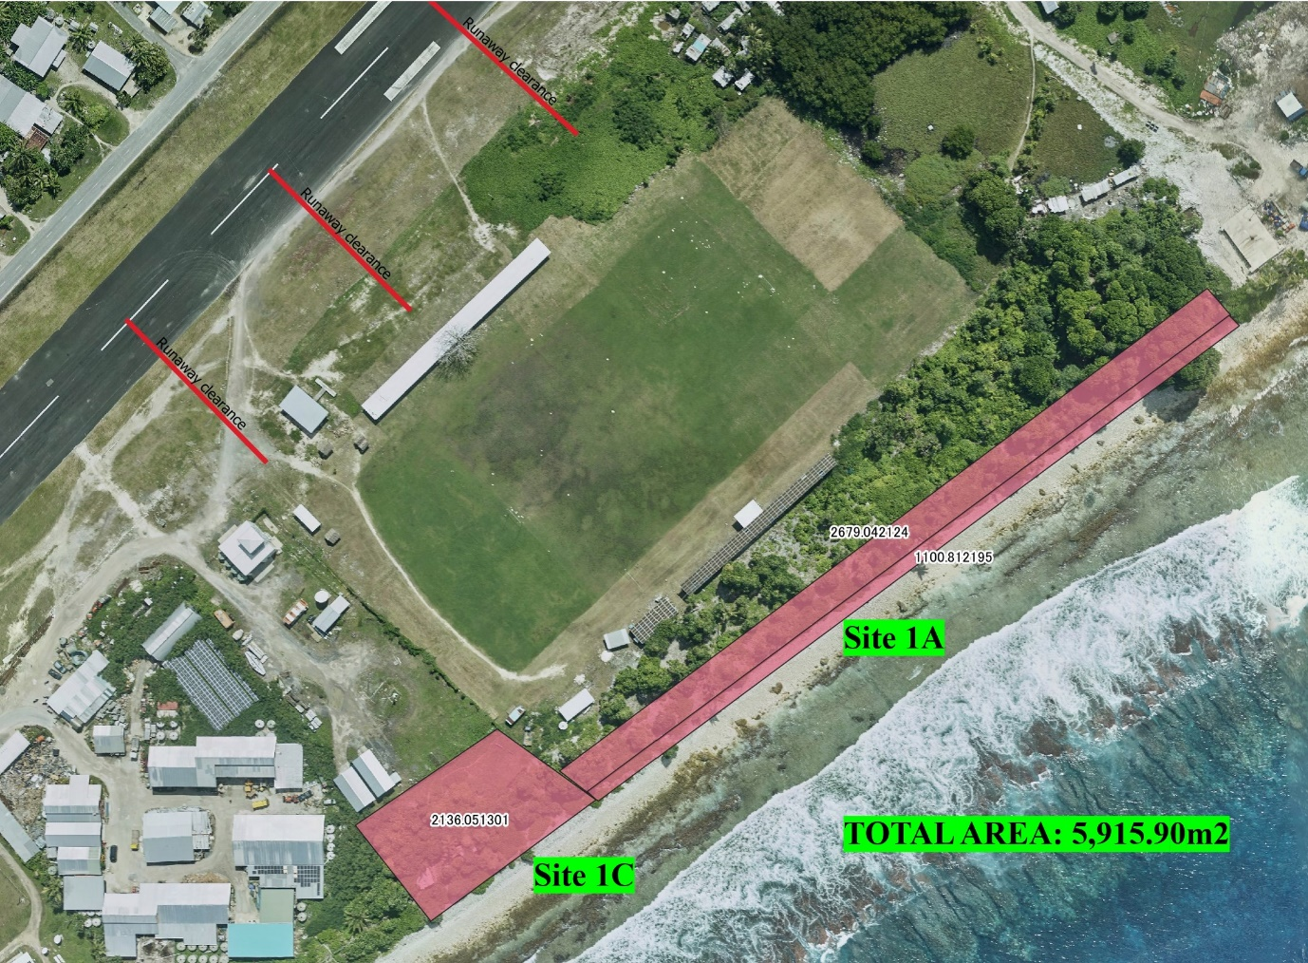
Figure 1: The two sites for the project (Site 1A, ,1C) identified for installing solar PV arrays.

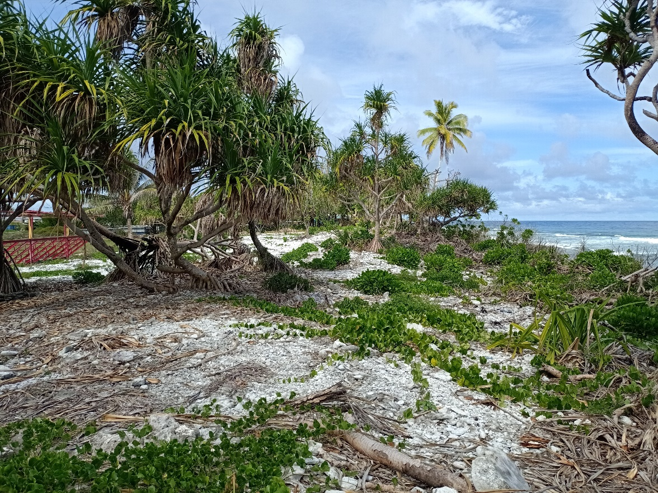
Figure 2: Project site 1A located at the eastern side of the Tuvalu Sports Ground closer to the coastal beaches.

Site 1C: oceanside of the new aviation tower boundary

This site is located at the rear of the new aviation tower boundary towards the oceanside (Figure 3), with rubble ridges and coastal vegetation along the coast. It is connected to the southern part of Site 1A, most of it is wider than Site 1A with a rough and rocky surface. The total area is approximately 2,136m², and it is expected that 558 solar panels can be accommodated on this site. The land is government lease land, which was approved by the government for installing solar panels.
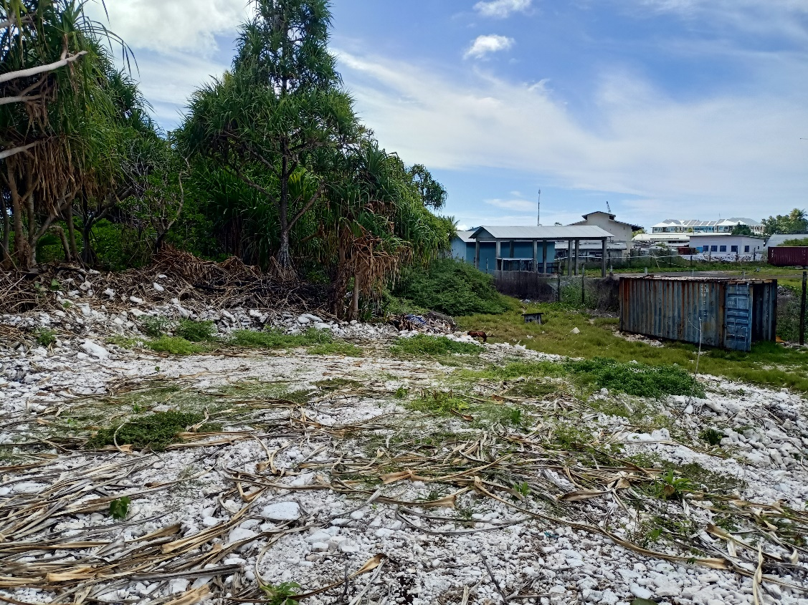
Figure 3: Project site 1C behind the new aviation tower fence, closer to the coastal beaches.
Possible future planning/restructuring may later include the consideration of mounting the solar panels on building rooftops. For example, Site B, a (Table #1 below) rooftop mounted option, was considered as part of the Project and in the Preparation of this ESMP. Any proposed installation on the rooftop will require further due diligence and updating of this ESMP.

Alternative Sites Considered
The selection process for the final sites included environmental and social safeguards screening to ensure that any significant negative impacts on the community or environment are avoided. Table 1 below shows the screening results supporting the final site selection. Figures 4-7 show the location of all the sites considered.
Table 1: Environmental and Social Screening of four potential sites for TESDP: site options assessment
Site Name | Advantages | Disadvantages | Planning Considerations | Overall Assessment
Site 1A and 1C  Ocean side of sports ground. | Government leased land – no acquisition needed  Less vegetation clearance than sites 3 & 4  No resettlement of pigpens required.  Good sized site | Some larger trees will need to be cleared | Project can immediately commence after ESMP approved; no resettlement activities required.  No budget requirement to fund mitigation impacts as per World Bank policy.  No need to facilitate pigpen relocation according to stringent WB requirements. | Avoids resettlement and avoids additional significant environmental impacts.  No impacts to project implementation within extension timeframe.  Might be possible to use the same design layout that has already been approved.
Site 1B  Hangar rooftop | Building on government leased land | Subject to further scoping if used | Use as a future alternative/with the restructuring of the project | Further scoping to be carried out in the event of use.
Site 2  Western side of sports ground | Government leased land – no acquisition needed  Least amount of vegetation clearance  No resettlement of pigpens required | Site of future stadium development so may require future integration.  Smallest of the four sites, design team will need to advise if the site is big enough. | Design will need to account for future stadium development.  Project can immediately commence after ESMP approved; no resettlement activities required.  No budget requirement to fund mitigation impacts as per World Bank policy.  No need to facilitate pigpen relocation according to stringent WB requirements. | Avoids resettlement and avoids additional significant environmental impacts.  No impacts to project implementation within extension timeframe.  Further design and planning work required to account for future integration with stadium and assess size of site.
Site 3  Behind PWD – Agricultural Nursery | Government leased land | Social: Requires relocation of about 79 pigpen structures. To comply with stringent safeguard policy this requires detailed consultation, development of an ARAP and allocated funds.  Environment: Requires clearing of large number of pandanus trees of this site and relocation site.  Site 3 has a coastal berm and would need to be levelled which would remove the berm that protects the coastal area.  Funding: Required budget allocation for mitigation measures.  Estimated average cost to replace pigpen structure: AUD $3,000 X 79 structures (AUD $237,000). | Environmental: Would need to determine whether removal of berm would create increased vulnerability to inundation  Social: Need time to conduct consultation with pigpen owners. Due diligence work will be required as per WB policy. It will take some time.  Involuntary settlement policy is triggered if choose this site.  Need mitigation measures as per OP 4.12 is Category B requiring compliance.  Will require preparation of a Resettlement Plan and updated ESMP.  Will require sizeable funding from project or government by November 2022 at the earliest to facilitate payment of pigpen owners prior to their relocation.  Need consultation and agreement of pigpen owners on compensation based on replacement value of affected assets as per WB involuntary resettlement policy (OP 4.12).  Need to negotiate and compensate landowners prior to relocating any pigpens.  Need to identify, assess and prepare pigpen relocation site including improved waste management facility construction prior to relocation of pigpens. Additional ESMP needed.  Require site resettlement completed by March 2023 to complete implementation in time. | There will be environmental and social impacts requiring mitigation measures and funding.  Significant risk of not completing the assembly/construction of the solar PV plant by the end of the extended project closing date.
Site 4  Behind Taiwanese Garden and Prion Compound | Government leased land  Social: No pigpens and other private structures on site. | Environment: Well-established coconut trees (behind prison compound) will need to be cleared. Will also require clearing of large number of pandanus trees.  Removal of trees will remove the protective function they provide (breeze, shade, coastal protection, etc.)  Further environmental assessments would be required.  Project support: Taiwan Garden clearly stated concern for removal of trees.  Funding: Required budget for additional environmental assessment.  Need to comply with stringent WB safeguards policy. | Environment: Environmental impact assessment requirement.  Will delay the project and will require funding to be allocated for mitigation measures such as coastal protection from cutting dense vegetation. | There will be environmental and social impacts requiring mitigation measures and funding.  Significant risk of not completing the assembly/construction of the solar PV plant by the end of the extended project closing date.

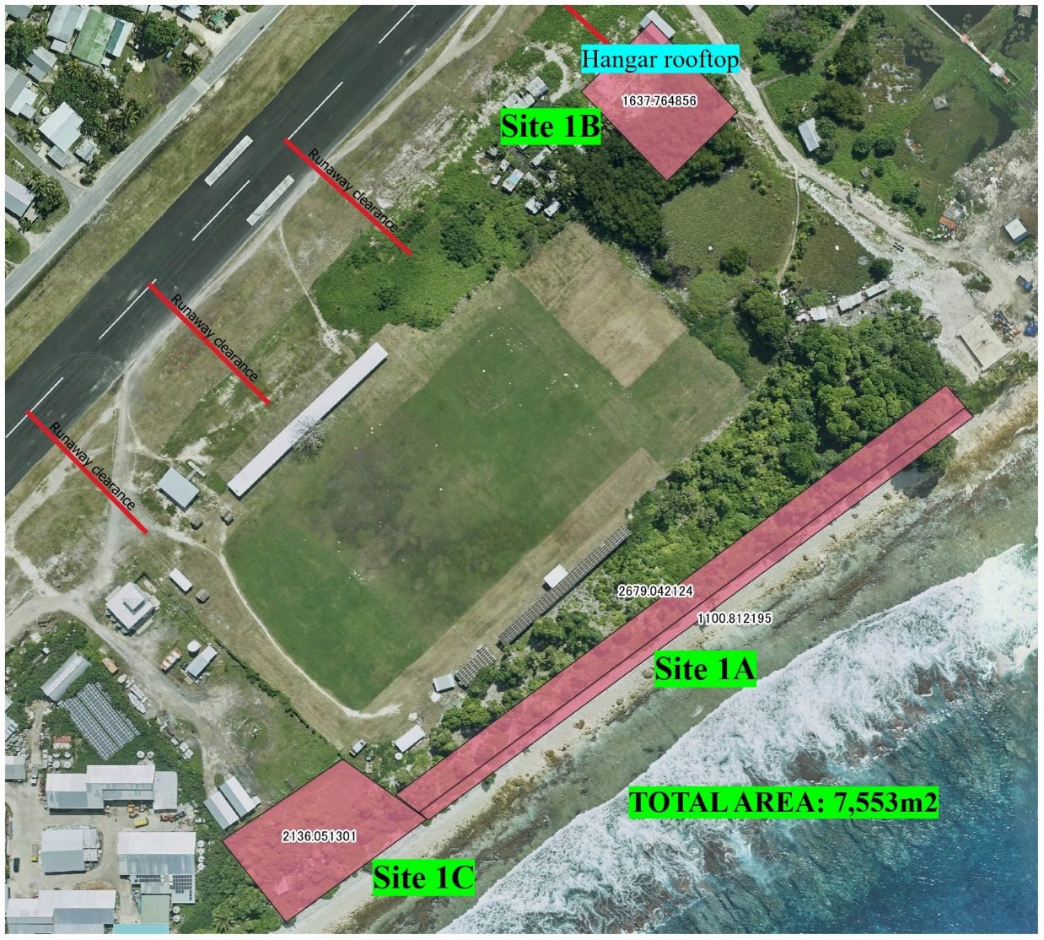
Figure 4. Site 1A, 1B and 1C.

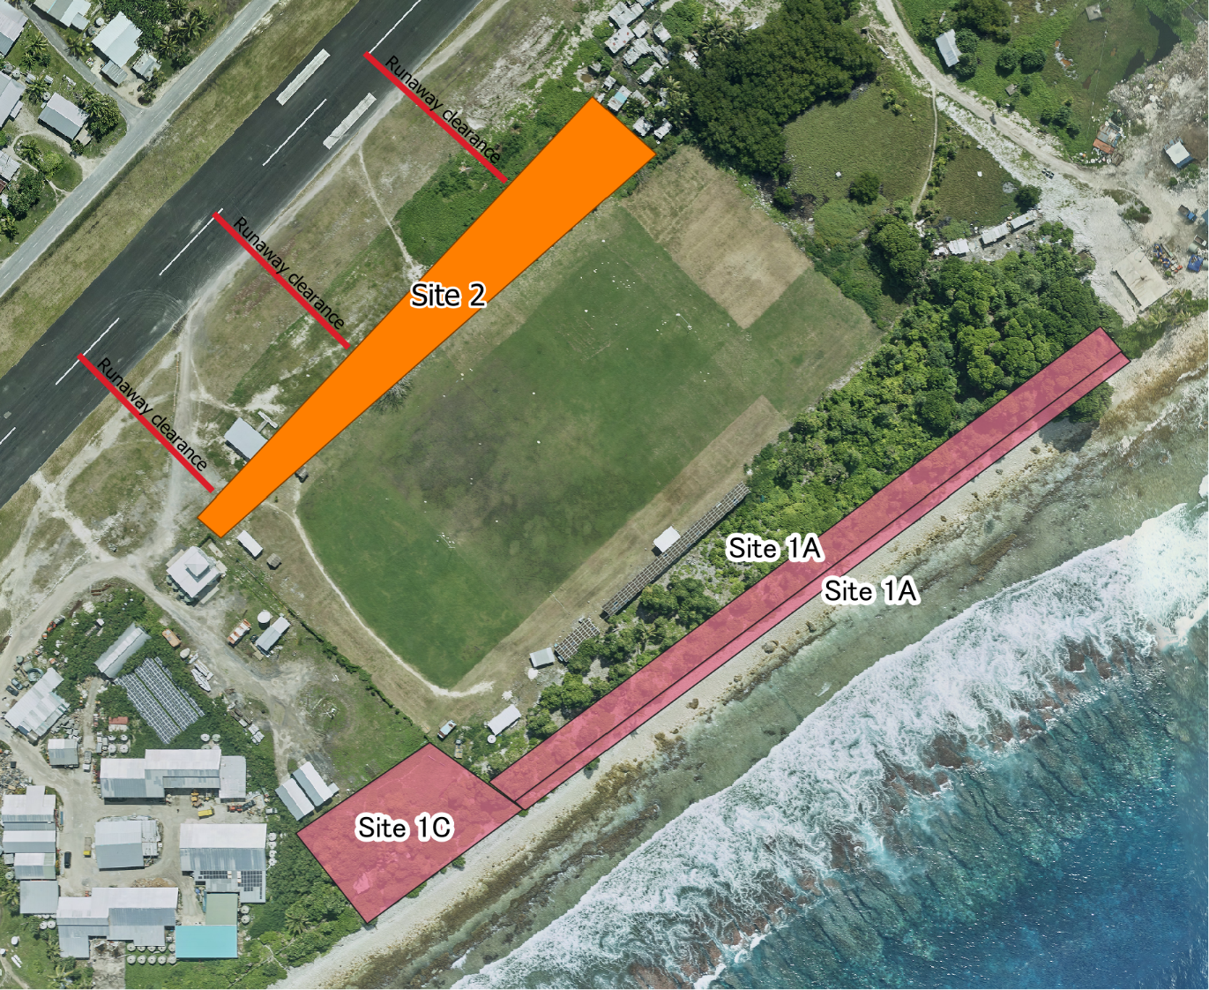
Figure 5: Site 1A & 1C adjacent to the ocean and Site 2 at the western side of the sports ground.

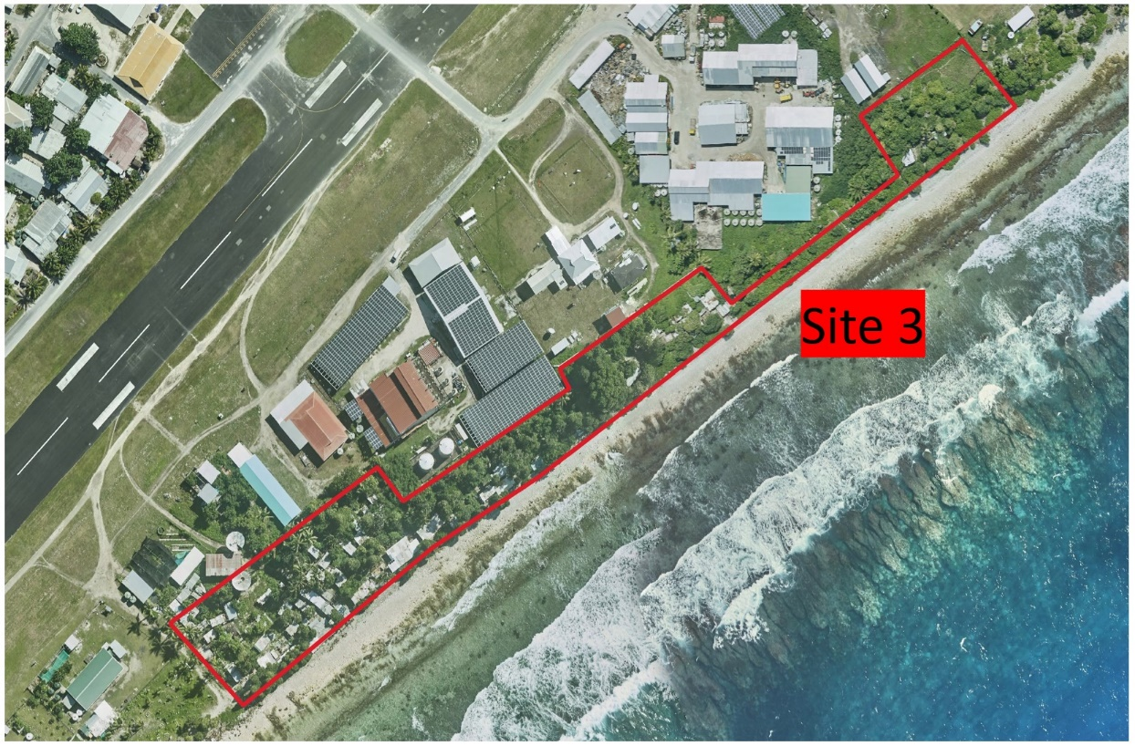
Figure 6: Site 3 is located behind PWD -Agriculture Nursery.

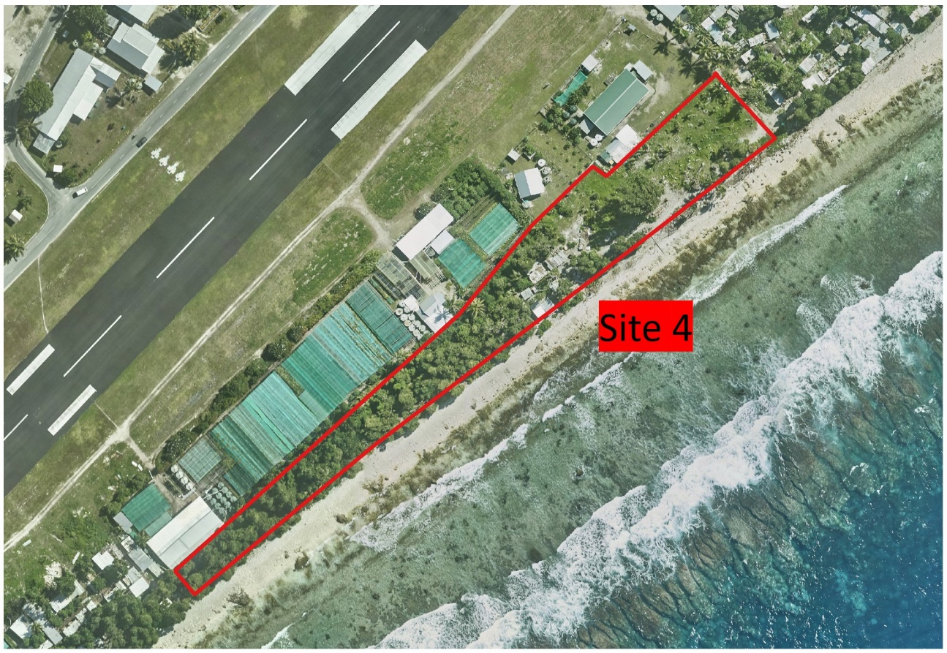
Figure 7: Site 4 is located behind the Taiwanese garden and Prison compound.

Battery Energy Storage Site
The BESS is to be located in Funafuti at the TEC power station (Figure 8) under the existing 350kW PV array. Batteries and inverters are to be collocated. As there are existing concrete footings and pillars in the proposed location, maneuvering the BESS equipment into its final location will require planning.

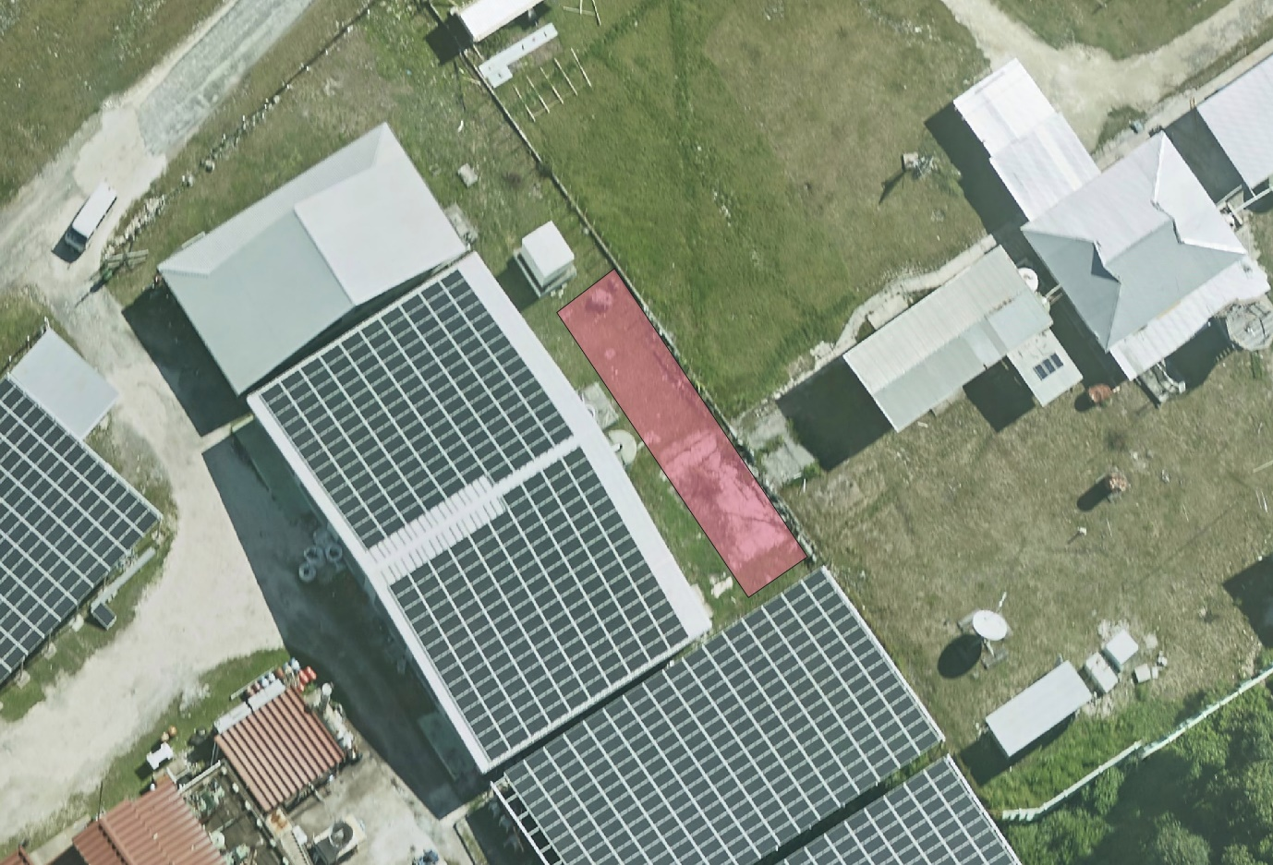
Figure 8: The location site of solar battery (pink colour) within the TEC compound.

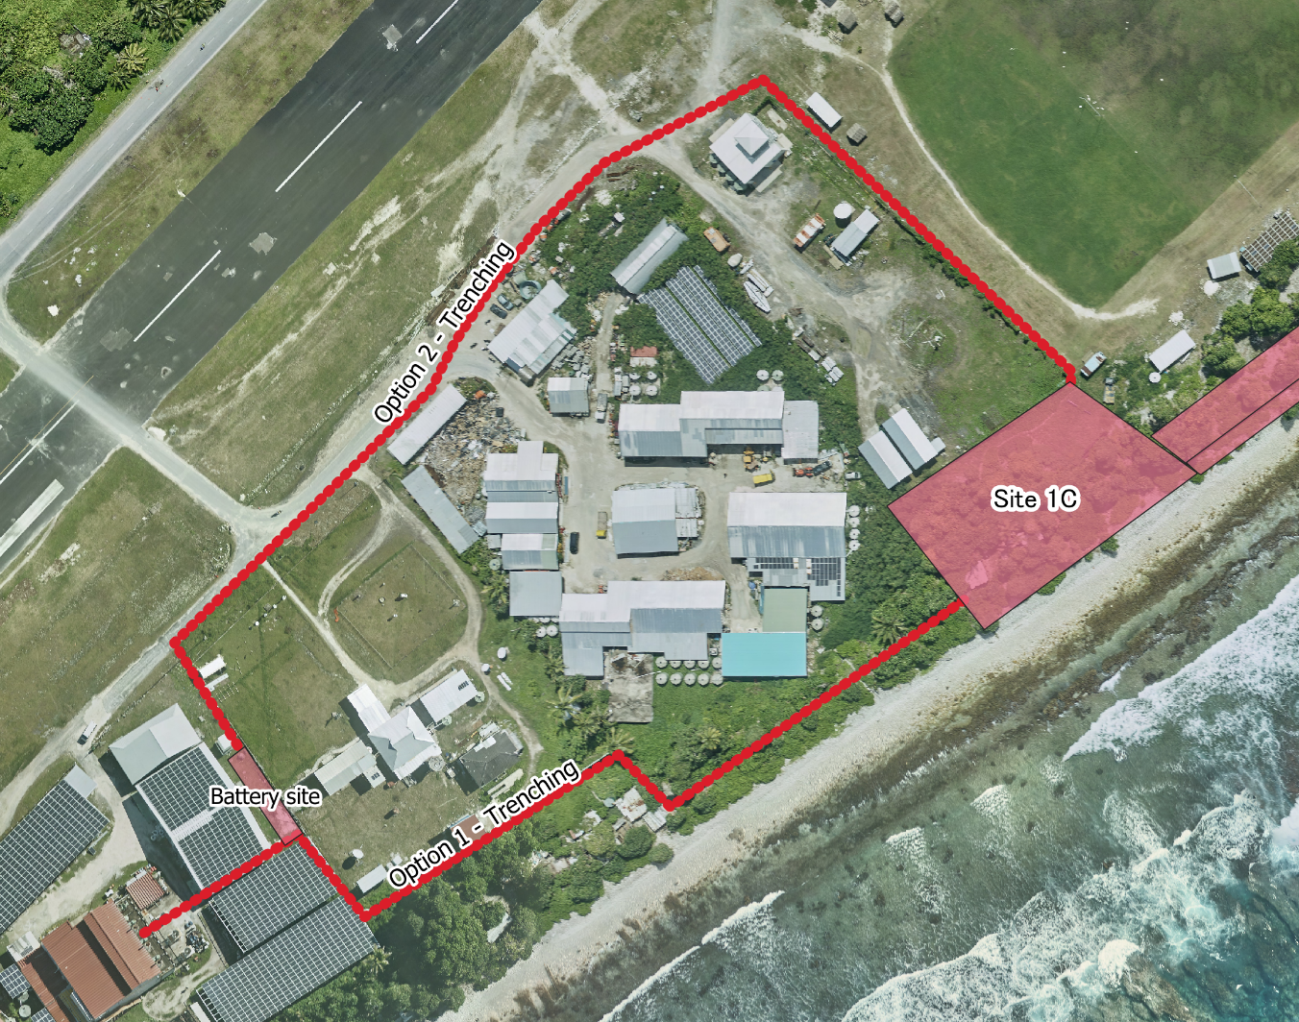
Figure 9: Options 1 & 2 routes for trenching the cable from the solar PV panel to BESS and grid system.

Ancillary Project Components
It is expected that there will be ancillary works associated with the installation of the solar PV and BESS systems on Funafuti. The final scope of these works will be confirmed during the detailed design phase, but it is expected to include the following:

Cabling and Trenching: All cabling is to be installed in accordance with internationally recognized standards and codes such as AS/NZS 3000:2007. The 11kV of cabling will be installed underground (see routing options in Figure 9). Contractors are advised that any cabling installed underground will be subject to salt water immersion at times. The selection and protection of the cables must account for this.

For each of the site options, including the preferred site option Site 1A and 1C, sections of short trenching works will be needed to connect the solar array to the nearest grid connection point at the TEC compound. The trenching will require the clearing of an approximately 1-meter-wide corridor of low growth vegetation either Option #2) alongside the access tracks around the runway at the front of the properties or Option #1) along the rear fence line of the properties. Routing option (#2) is preferred as there will be no impact on informal piggeries and will follow existing roadway alignments. This will be confirmed in the C-ESMP. The BESS site will require approximately 200m within the TEC compound.

Aggregates: It is anticipated that sand and aggregates will be required for the civil works at the solar array site and the BESS installation site. No sand or new aggregate extraction will be undertaken within Tuvalu for this project. The sand and aggregate required for the project will be imported.
Haulage: Equipment and materials will need to be transported from the Funafuti Port and/or TEC compound to the project sites. At this stage, the volume of imported items is unknown but possibly involves sections of pre-cast concrete and aggregates to cast any other concrete in situ.
Transportation between the port, the project sites and TEC site passes through villages and the dense Funafuti urban and administrative center before crossing the runway to the TEC compound. The roads are in relatively good condition and are wide enough to accommodate heavy vehicles, however the road between the port and Funafuti is heavily trafficked with pedestrians, motorbikes, cars and vans.
Laydown Site: A laydown site (or sites) will be required for the storage of equipment and staging of construction works for the solar array and BESS installations. Currently, the eastern side of the runway near the sports ground being used as a laydown site for all the project’s equipment. It is anticipated that the site(s) will be used for the storage of machinery and equipment as well as pre-cast concrete structures, a first aid station and storage of portable generator. It may be necessary to produce concrete in situ during installation of the array and energy storage pads. Concrete batch compounds will be installed in close proximity to the sites, either at the solar array site or in close proximity to the TEC compound. There is likely also a need for stockpile sites to store aggregate and to store any excavated materials from levelling activities at the solar array site.
Laydown sites, stockpile sites and concrete batching compounds are expected to be installed on government land near the sports ground. Sites will be detailed and assessed in the C-ESMP.
Waste: Waste is expected to be generated in the form of excess concrete, packaging materials, general construction waste, excess excavated materials and used oil. Tuvalu has a municipal landfill; however, it is operating at capacity and is only suitable for disposal of general office waste. It is not suitable for any other type of project waste. All other wastes will be disposed of offshore at a licensed facility. There are no facilities on Tuvalu to dispose of hazardous materials, however the Waste Management Department (WMD) has provisions in place to support the disposal of hazardous materials off shore. The WMD also runs the islands recycling export program and should be consulted on the disposal of any recyclable materials. Reduction and reuse should be waste management strategies employed by the Contractor.
Hazardous Substances: If concrete is produced in-situ at the solar array sites, it will be in a coastal environment which increases the environmental risk to the marine environment from concrete waste water and slurry. For any levelling works at the solar array sites, an excavator will be needed, which also increases the environmental risk from the fuel and oil needed for the excavator. As there is no electricity at the solar array site, the Contractor will need to provide their own power and diesel will be used at the solar array site and stored at the laydown site(s).
Construction water: There is no reticulated water supply available at the identified sites. Contractors are required to make their own arrangement for sourcing this. On Funafuti potable water is also provided by one of three desalination plants. Water is not reticulated. Droughts have led to severe drinking water shortages on the islands in recent times.
The groundwater lens on Funafuti is contaminated with sea water. In 1972, Cyclone Bebe, a large storm event, caused sea water to flood the island and infiltrate the groundwater. It is no longer a potable water supply.

Land Acquisition
The solar array installation site is within the two identified sites and the BESS site is within the TEC compound all of which are leased by the Government of Tuvalu under a long-term lease across the majority of the island of Funafuti. The Cabinet of the GoT has approved the sites for use by the TESDP and has determined the maximum footprint which may be used for solar array installation under the Project.
The trenching routes between the solar array site and the TEC compound point do not pass through any villages, residences or land uses that may be adversely affected by these works. Temporary access to the trench corridor will be required. Site visits have established that no food crops or otherwise cultivated areas will be disturbed during the trenching works. Only low-level vegetation will be cleared and then replaced. Consultations with users of the areas along the trenching route to ensure that any disturbance will be kept to a minimum.
There will be no resettlement or livelihood impacts (involuntary or otherwise) of any persons associated with the implementation of the TESDP.

Environmental and Social Context
The ESDP ESMF describes the general natural and social environment of Tuvalu in some detail. The sections below refer only to the subproject footprint.

Land Use
Land availability on Funafuti is limited and informal land uses such as piggeries and gardens have encroached on idle government lease land.
Site 1A: The site is on the eastern side of the Tuvalu Sports Ground, which falls within the coastal vegetation zone on the oceanside of the island, lying perpendicular to the length of the sports ground. The ground surface is largely coralline rubbles with uneven ridges covering the coastline. Most of the trees were recently cleared, and the vegetation that remains are not considered valuable to Tuvaluan culture (Figure 10).
Site 1C: This site is on the southeastern side of the Tuvalu Sports Ground, at the rear of the new aviation tower boundary and the site is government leased land with undeveloped spaces, and high rubble ridges at the coastal vegetation.
Along the length of Site 1A and Site 1C the beach is rocky and leads to a reef flat, of approximately 150m in length. The reef flat is, again, undulating and uneven but devoid of any significant marine life. The wave energy is high at all tide levels and the reef flat is underwater at low tide.

Terrestrial Environment
Funafuti is a narrow, densely populated landmass which has undergone significant anthropogenic changes. Coconut, breadfruit and pandanus dominates the landscape as do pawpaw and other food crops. The vegetation has been affected by the contamination of the freshwater lens with salt water and subsistence crops require careful cultivation and application of compost and nutrients to sustain the crops. In Tuvalu nearly 65% of the flora is not native.
The land surrounding the stadium is considered to be previously disturbed land. The vegetation is characterized by large grassy areas with scattered coastal trees and low-lying scattered vegetation amongst the existing infrastructure along the shoreline.
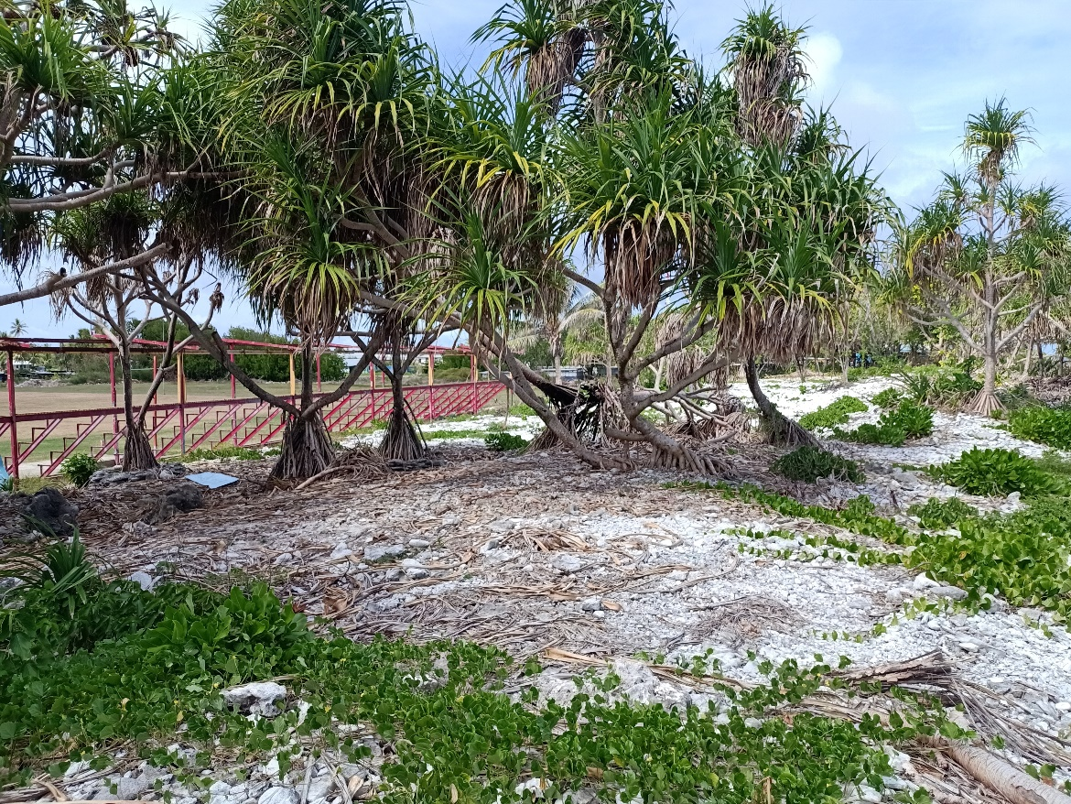
Figure 10: Vegetation at the project site 1A

Marine Environment
The marine environment immediately behind Sites 1A and 1C consists of upper intertidal rocky beaches (Figure 11), intertidal reef flat and sub-tidally, the reef slope. The intertidal reef flat is rocky and undulating with several peaks and troughs across its width. The habitat is bare rock with sporadic coral species adapted to the high energy environment and some sparse patches of low growing coralline and turf algae. Benthic invertebrates are observed infrequently.
The marine environment of Site 1A & 1C consists of upper intertidal sandy beach, Intertidal sand flats and the subtidal deeper sandy lagoon floor. The upper sandy beach is currently impacted by infrastructure development activities of the neighbouring land reclamation works. An excavator was observed driving along the beach during the site survey. The intertidal zone is scattered with occasional rock where collections of small gastropod species can be observed. The sandy lagoon floor is populated with scattered coral bomboras and outcrops.

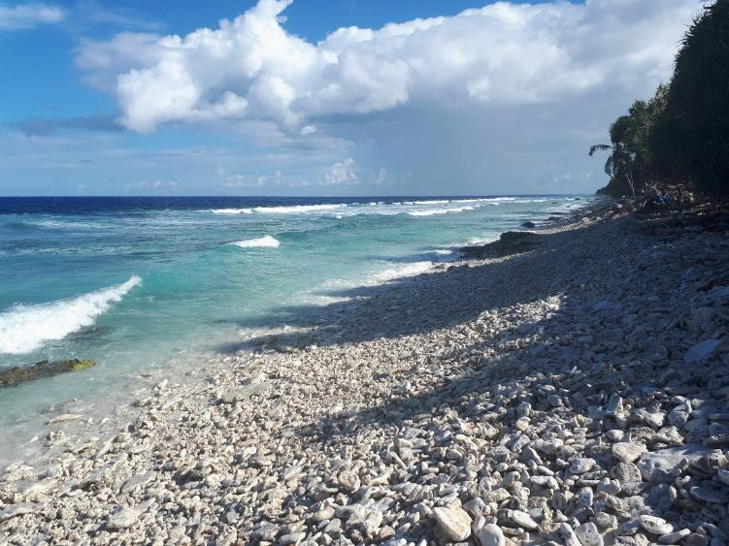
Figure 11: Coastline immediately behind stadium area

Climate Change Threats
Tuvalu is extremely vulnerable to climate change. As sea level rises, inundation events will become more common, and it is expected that many islets will eventually be submerged. Climate change predictions are for increased intensity and frequency of intense rainfall days, increase in annual and seasonal mean rainfall, and less frequent droughts. The frequency of cyclones is predicted to decrease.
Increases in sea temperatures and ocean acidification will continue to cause coral bleaching in the reefs. This has a catastrophic effect on the reef ecosystem, and the ability of the reef to protect the lagoon from swells and storm surges.

Waste Management
There is one ‘landfill’ on Funafuti where all collected waste goes. Waste is not covered or buried; it is a health and safety risk and is likely to be polluting the ground and marine environment. Due to a lack of space on Funafuti, this solution to waste management is not sustainable. Litter is also a big problem on the island. There are no facilities for recycling and no facilities for hazardous waste treatment or disposal.

Environmental and Social Risk Management Legislation and Policy

Tuvalu Environment Protection Act 2008 and 2014 EIA Regulations
The Environmental Protection Act 2008 (henceforth the ‘EP Act’, or ‘the Ac’') covers impact assessment, international and regional environmental obligations, biodiversity protection, climate change strategy and waste management.
Under Section 18, the Department of Environment (DoE) has the power to create regulations to provide for a system of environmental impact assessment to be applied in Tuvalu.

EIA Regulations 2014
The 2014 Tuvalu Environment Protection (Environmental Impact Assessment) Regulations prescribes, under Schedule 1 Development Activities Section 9(n), that an electricity generating station is considered a development activity. All development activities require a development consent, issued by the Department of Environment. As part of the consent process, a Preliminary Environmental Assessment Report (PEAR) must be prepared by the developer (TEC).
The process, as prescribed by the 2014 regulations, is as follows:
- All persons proposing to undertake any development activity to which these regulations apply must, prior to the commencement of the activity, – (a) notify the Department of Environment of the proposed activity; and (b) apply for a development consent under these regulations. All notifications must be accompanied by an application fee of $500.00.
- A PEAR shall contain the following particulars
  - a brief description of the development proposal;
  - a brief description of the area to be affected and the nature of the proposed change to the area (including a location map and site plan);
  - a brief justification for the development proposal;
  - an assessment of all reasonably foreseeable adverse and positive impacts, including long-term and short-term, primary and secondary consequences;
  - an indication of possible alternatives considered to mitigate any identified adverse impacts; and
  - an indication of measures that the proponent intends to take to mitigate or avoid identified adverse impacts.
The Department of Environment will assess the proposal and approve the development consent,
In the event that the Minister decides that, due to the scale of the potential risks of the project, a full Environmental Impact Assessment (EIA) is required, this will be prepared in accordance with the requirements of the EIA regulations.
In either case, this ESMP is expected to form the core of a PEAR or EIA submitted.

Schedule 1 of the Environment Protection Act 2006
Schedule 1 of the Environment Protection Act (EP Act) provides a list international convention to which Tuvalu has signed. This includes:
- United Nations Framework Convention on Climate Change (Adopted at New York on 9 May 1992).
- Cartagena Protocol to the Convention on Biological Diversity (Adopted at Montreal on 29 January 2000).
- Convention to Ban the Importation into Forum Island Countries of Hazardous and Radioactive Waste and to Control the Trans-boundary Movement and Management of Hazardous Waste within the South Pacific Region (Waigani, PNG, 16 Sept 1995).

World Bank Safeguard Policies
The World Bank’s environmental and social safeguard policies are a cornerstone of its support to sustainable poverty reduction. The objective of these policies is to prevent and mitigate undue harm to people, their livelihoods and their environment in the development process. The safeguard policies that apply to this project and described below are:
- OP/BP 4.01 Environmental Assessment
- OP/BP 4.12 Involuntary Resettlement
OP4.04 Natural Habitats and OP4.11 Physical Cultural Resources do not apply to the project at the time of project appraisal, but are described, in case issues come up during project implementation that are relevant to these two policies.

OP/BP4.01 Environmental Assessment
The purpose of Environmental Assessment is to improve decision making, to ensure that project options under consideration are environmentally and socially sound and sustainable, and that potentially affected people have been properly consulted. The policy defines procedures to screen and assess potential impacts and mitigation, prepare safeguard instruments, ensure public consultation and transparency and that there are implementation and supervision of commitments relating to findings and recommendations of the environmental assessment.
Environmental assessment has been undertaken in accordance with this policy and this ESMF is the safeguard instrument for the ESDP. For the projects to be developed during project implementation, the screening checklists will determine which environmental safeguard instrument is relevant for the specific project. In this case the ESIA and this ESMP.

OP/BP4.12 Involuntary Resettlement
Involuntary resettlement refers to management of adverse impacts of loss of, or damage to, land, assets or livelihoods, where the affected person has no choice. Land may be needed for this project to install electricity generation, storage and communications infrastructure. This may occur on government or private buildings, government leased land or ‘native’ land. Assets such as tree crops may need to be trimmed or removed to allow access to sites / infrastructure.
A Resettlement Policy Framework has been prepared and publicly disclosed as a safeguard instrument under this policy. As per the Project as defined in this ESMP, no involuntary resettlement (physical or livelihood) will result from this Project.

Other Safeguard Policies
OP4.04 Natural Habitats
The conservation of natural habitats is essential for long-term sustainable development. The World Bank therefore supports the protection, maintenance, and rehabilitation of natural habitats and their functions. The World Bank does not support projects involving the significant conversion of natural habitats unless there are no feasible alternatives for the project and its siting, and comprehensive analysis demonstrates that overall benefits from the project substantially outweigh the environmental costs.
In the environmental assessment for the ESMF, no threats to natural habitats were identified and this policy is not triggered for the TESDP. However, the screening and environmental assessment for each of the separate projects under the EDSP will require an assessment of the potential impacts on natural habitats in accordance with this policy.
OP 4.11 Physical Cultural Resources
This policy refers to the protection of physical cultural resources (including archaeological, paleontological, historical, cultural or spiritual artefacts and places, whether immovable or moveable). When the project is likely to have adverse impacts on physical cultural resources, the borrower identifies appropriate measures for avoiding or mitigating these impacts as part of the environmental assessment process. These measures may range from full site protection to selective mitigation, including salvage and documentation, in cases where a portion or all of the physical cultural resources may be lost.
In the environmental assessment for the ESMF, no threats to physical cultural resources were identified and this policy is not triggered for the TESDP. However, the ESMF provides guidance on identifying physical cultural resources for any subproject not yet defined, and how to avoid or mitigate any potential impacts.

Gender Action Plan
A Gender Action Plan has been prepared for the ESDP project. While this is not a requirement of the World Bank Safeguard Policies, ‘Gender and Development’ is part of the wider set of the World Bank’s Operational Policies, and is relevant to the consultation processes under the ESMF. All World Bank projects are required to be gender informed. The objective of the World Bank's gender and development policy is to assist member countries to reduce poverty and enhance economic growth, human well-being, and development effectiveness by addressing the gender disparities and inequalities that are barriers to development, and by assisting member countries in formulating and implementing their gender and development goals. This includes the prevention of sexual exploitation and abuse/ sexual harassment (SEA/SH), HIV/AIDS and gender-based violence (Section 5.1.2.3 and Appendix A, Workers’ Code of Conduct).

Impacts and Mitigation Plan
The ESDP has the potential to create a variety of impacts through the installation, commissioning and operation of the solar array and BESS. These potential impacts can be either positive or negative depending on the receptors involved and the activity. The impact of this project on the physical, biological and social environment has been assessed to determine likelihood and identify effective mitigation measures.
There are site-specific and component-specific impacts which have been identified and the significant impacts requiring specific mitigation are discussed below.
All impacts below are presented under the associated impact generating activity.

Key Identified Impacts
Section 5.2 describes all of the identified impacts for the solar array and BESS components of the project. The table also lists the key mitigation measures, the residual impacts following mitigation, the responsible party and the predicted cost of the measures. The tables include the applicable management requirements stipulated in the Solar PV Array Code of Practice, the Battery Code of Practice and the Construction and Earthworks Code of Practice in the TESDP ESMF.
In the sections below, some of the key impacts are discussed in more detail and are also included in the table.

Environmental Impacts During Construction Phase

Vegetation Clearance
The updated survey conducted at the project site and also land adjacent to the project site shows the majority of the vegetation has cleared recently by the government for constructing the sport facility. However, there were minor vegetation remained at the site 1A & 1C (Figure 12 and Table 3), which were counted by the PIU that necessarily need to be cleared off for installing solar panel. All these wild vegetations were non edible plants or not valuable for cultural purposes due to wildness and not bearing fruits. Cleared vegetations can be transform in to green wastes by the Department of wastes for gardening purpose especially leaves and branches, but for hardwood trunk can be used by government for constructing purposes. The surveyed covered vegetations within the project site and also vegetation adjacent to the project site that obstructed the sunlight direction. Counting of individual vegetations covered from grass roots plants up to broadleaf canopy trees. Pandanus tress dominated the entire project site with an average of 84 plants per site, within the project site and also adjacent to project site, follow by few Barringtonia asiatica, Guettarda speciosa, coconut trees, Morinda citrifolia and Ficus tinctoria.
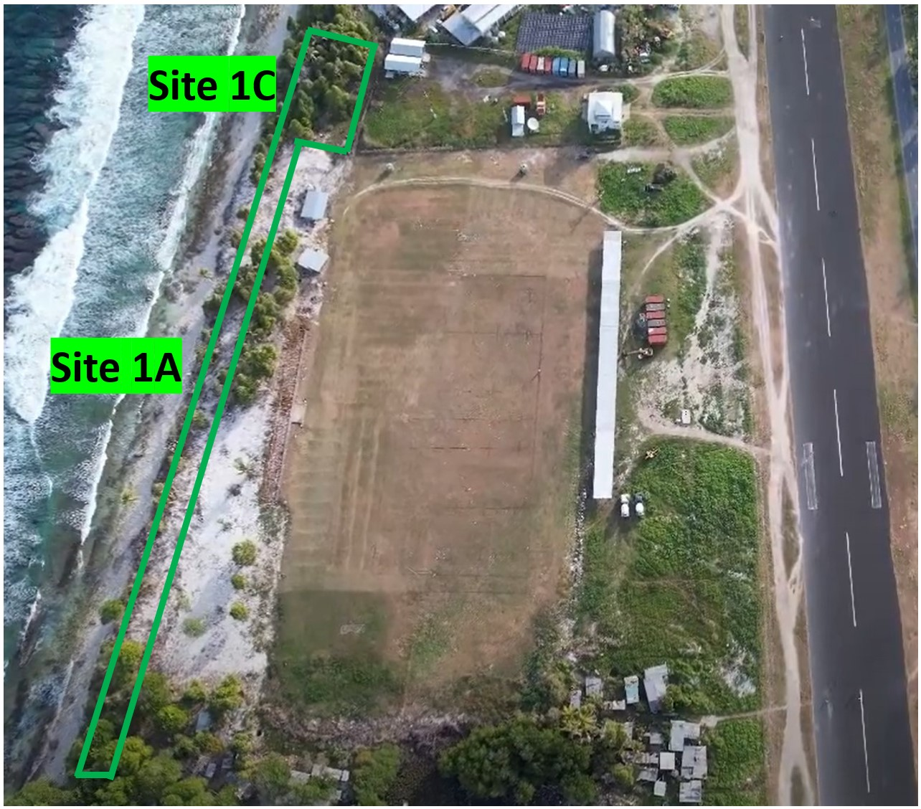
Figure 12: Project site (1A & 1C) with minimal vegetation that needs to be cleared.

Table 3: Amount of vegetation within the project site and land space adjacent to project site.
Vegetation Name  (Scientific name) | Project Site  1A (# of trees) | Project Site  1C (# of trees) | Adjacent to Project site  (# of trees)
Pandanus tectorius | 93 | 66 | 92
Barringtonia asiatica | 10 | 0 | 10
Guettarda speciosa | 6 | 4 | 2
Cocos nucifera | 2 | 2 | 2
Morinda citrifolia | 0 | 3 | 1
Ficus tinctoria | 1 | 0 | 0

To mitigate the loss of patch vegetation in Site 1C it is necessary to relocate the affected vegetation . This can be transferred to Site 4 (behind prison compound and Taiwanese garden) before any civil works commence at the project. The contractor will be responsible for transferring those affected vegetations to Site 4, while broadleaf plants impossible for transferrable can be cut down into pieces and used by the Department of waste for shredding into green waste for garden purpose.
In anticipation of imminent civil works at Site 1C, an investigation and offset plan should be developed to address the loss of remnant or patch vegetation. The first step involves conducting a thorough flora assessment of Site 1C on identifying and prioritizing transferrable plant species. Strict adherence to best practices during the translocation process to Site 4 is emphasized to minimize stress on the vegetation. Compensatory measures will address the unavoidable cutting of vegetation that cannot be relocated. These measures will also include the responsible management of green waste through shredding for garden purposes. A post-transplantation monitoring program should be established to assess survival rates and adaptation, complemented by ongoing maintenance activities such as watering and pest control, as necessary, to ensure the continued well-being of the transplanted vegetation. Engagement with stakeholders (the local community and environmental organizations) is a fundamental aspect of this plan involving the proactive communication of the vegetation relocation strategy. Continuous feedback mechanisms should be established to address concerns and foster understanding and support. Detailed documentation, covering aspects such as species inventory, transplantation procedures, and monitoring reports, will be maintained throughout the entire process. Regular updates will be provided to project stakeholders and regulatory authorities to ensure transparency and accountability.

Coastal Protection
The rubble ridge at the coastal line provides a coastal protection against waves and erosion that may impact the project site. Historically, the ridge is quite higher than the sports ground surface with no evidence of being overpassed by storm surge or cyclone waves. The overall beaches adjacent to the project site has no evidence of erosion or exposure to risks, the beach’s front is gradually stabilized by rubbles that reduce the wave strength approach the shoreline.

Concrete Production
Environmental impacts associated with concrete production is water pollution. Waste water and slurry from concrete production will have a high pH level making it alkaline and contains chromium. Highly alkaline water can result in the death of marine organisms should it enter the marine environment. There are also impacts associated with concrete waste water leaching into the groundwater and causing contamination.

Importation of Equipment and Materials
Solar panels and all associated structures and equipment will need to be imported into Tuvalu. Additionally, sand and/or aggregates may be imported for the concrete works. If imported consignments are not properly treated and/or washed before shipping, there is the risk of introducing non-native and potentially invasive plants, animals and disease. The introduction of harmful species to small island nations such as Tuvalu, who have a naturally low level of biodiversity, can be devastating to the local ecosystems, flora and fauna. It is also possible to import diseases such as foot and mouth disease which would have devastating impacts on local livestock.
Invasive marine organisms can also be introduced to the marine environment by unregulated discharge of cargo ship ballast water.

Handling and Storage of Hazardous Materials
Works at the solar array installation site will be undertaken in close proximity to the coastal marine environments. Works will include the use and storage of hydrocarbons (fuel and oil) for the operation of machinery and power generation.
There is a risk of significant spills contaminating the marine environment adjacent to the solar array site if the appropriate management measures are not effectively implemented.

Social Impacts During Construction Phase

Construction activities on or adjacent to Recreational Spaces
During construction, it can be expected that there will be some pedestrian and traffic management required at the installation sites adjacent to the stadium. It can be expected that the recreational use of the stadium area and beach front areas would be limited to some degree and therefore cause an impact to the recreational public. Traffic management during installation may mean temporary reduced access to areas such as parking spaces and shaded stands which may have an impact on local traffic movements and personal comfort of spectators. These impacts are expected to be short term and will cease completely once installation is complete.

Haulage of Materials and Equipment
The haulage routes will pass through residential communities and likely past other sensitive social receptors (schools, hospitals, churches, etc). The increased level of noise, dust and vibration, and traffic hazards is likely to impact on the quality of daily activities in these communities and associated with these facilities. This impact will be short term and will cease completely once haulage is completed.
There is also the possibility of damage to the existing road surface associated with haulage of heavy loads. Damages to road surfaces can cause a traffic hazard and can also lead to a faster rate of overall road surface degradation in the long term. As the exact haulage route between the port and TEC compound will be determined by the contractor in their Traffic Management Plan, the existing road surface condition has to be assessed. The area of the highest risk will be between the port and Funafuti where the traffic and pedestrian levels are much higher, and the sensitive receptors are densely located. The identified haulage route should avoid high risk areas, and where unavoidable, measures should be put in place to reduce the risks and included in the traffic management plan.

Sexual Exploitation and Abuse/ Sexual Harassment (SEA/SH), HIV/AIDS and Gender Based Violence
There are increased SEA/SH risks as a result of influx labour recruited from outside the local community with associated such as increased instances of HIV/AIDs and other sexually transmitted inflections (STIs). Additionally, there is a risk of increased instances of gender-based violence (GBV) in the home as a result of increased household income through employment changing household dynamics. . As such the contractor will have responsibility for implementing actions to prevent instances of SEA/SH, HIV/AIDs and GBV, namely through delivery of training and ensuring workers are briefed on and accept the Workers’ Code of Conduct (Appendix A).

Mitigation Tables

Solar PV Installation Design and Pre-Construction Phase Management Plan

Environmental or social impact | Design and Pre-Construction Mitigation Actions | When | Costs | Responsible
General / all impacts | - Feasibility and detailed design studies to be informed by the ESMP. All impacts shall be avoided in the first instance or reduced through application of mitigation measures in this ESMP. | During design process | Part of standard practices | Contractor
General / all impacts | - Complete and submit PEAR/ESMP to the Tuvalu Department of Environment in accordance with the Environment Impact Regulation of the Tuvalu EPA 2008 environmental permit requirements.  - Prepare the C-ESMP and Incorporate consent conditions. | One month prior to commencement of civil works | AUD$500 application fee | Contractor supported by TEC PIU Safeguard Specialist & CPMO
Design of Solar Array Installation Site and associated construction sites. | - Undertake studies in compliance with this ESMP/C-ESMP.  - Site will be designed to include protective locks, fences, signage, etc. to protect the public from hazards  - Supplier/Manufacturer contract clause to provide for recommended removal options of spent solar panels from Tuvalu.  - Avoid installations impacting on informal piggeries.  - Cable laying to be designed to maximize use of existing conduit where possible.  - Laydown sites, stockpile and concrete batching compound site options are to be defined and assessed, and risk and impact mitigation measures defined during the preparation of the C-ESMP and submitted in advance to the GoTV and World Bank for No Objection. | During design process, prior to final design approval | Minor, part of standard practices | Contractor
Design of Battery Energy Storage System | - BESS will be designed to ensure worker safety – this can include fencing and signage for battery storage area.  - Protect public health and safety by preventing unauthorized access to batteries by providing locked facilities.  - Protect the environment by housing batteries in covered structure, with concrete floors. Floors should be bunded to contain any acid spills.  - BESS to be installed on structures that elevate units above inundation risks including: Highest Astronomical Tides (HAT), high rainfall events and maximum storm surge estimates. | During design process, prior to final design approval | Minor, part of tender requirements | Contractor
Waste Management | - The Contractor shall develop a Solid Waste Management Plan in accordance with the guidelines included in Appendix B of the ESMP.  - SWMP plan will stipulate removal of all solid and hazardous waste off Tuvalu; compost or local disposal of vegetation as part of a vegetation relocation-offset plan  - All Project staff will be trained on this plan and attendance will be recorded.  - It is a requirement to dispose of spent batteries or solar panels off Tuvalu during the operational phase of the project. The SWMP should provide TEC with a procedure for this during O&M | Prior to commencement of works | Minor, part of standard practices | Contractor
Water Supply and Management | - Contractor to design water catchment and/or storage at the solar array installation site to supply water for construction needs.  - Contractor to make provision for potable water for workers at solar array installation site.  - Any sanitation facilities supplied for the workers by the Contractor at the solar array installation site must be temporary and must include a self-contained septic system or be a composting toilet.  - Water sourcing shall only be through rainwater catchment or purchased from the desalination plants. | Prior to commencement of works | Minor, part of standard practices | Contractor
Traffic Management | - The Contractor shall develop a Traffic Management Plan. The TMP shall also include requirements that are in accordance with the stipulations of this ESMP | Prior to commencement of works | Minor, part of standard practices | Contractor
Spill Prevention and Emergency Response | - The Contractor will have a spill prevention and emergency response plan in place to account for all potential instances.  - The plan will include:  - Measures to avoid spill in the first instance including use of drip trays for refueling, use of hard stand for maintenance and repair, covered and bunded storage areas for hazardous substances, etc.  - The person who has identified the leakage/spillage shall immediately check if anyone is injured and shall then inform the Supervisor.  - In such cases, all personnel shall take immediate action to stop and contain the spillage / leakage;  - The Contractor shall arrange maintenance staff with appropriate protective clothing to clean up the chemicals/chemical waste. This may be achieved through soaking with sawdust (if the quantity of spillage/leakage is small), or sand bags (if the quantity is large); and/or using a shovel to remove the sand / topsoil (if the spillage/leakage occurs on bare ground);  - Contaminated sand and materials must be handled as hazardous waste (see above).  - The Contractor shall prepare a report on the incident detailing the accident, clean-up actions taken, any pollution problems and suggested measures to prevent similar accidents from happening again in future. The incident report shall then be submitted to TEC for review and submit to the Department of Environment.  - All Project staff will be trained on this plan and attendance will be recorded. | Prior to commencement of works | Minor, part of standard practices | Contractor
Recruitment and management of workers | - The Contractor will engage locals workers wherever possible, and prioritise local spending for food and services wherever possible. Ensure equitable access for men and women.  - All overseas project staff will abide by Tuvalu immigration policy and provide all required documentation, including health checks. Overseas workers will undergo cultural familiarisation induction upon arrival and sign a workers’ code of conduct applicable for the duration of their contract (Appendix A).  - Overseas workers will have the technical skills and experience for solar PV array installation. | During worker recruitment process | Minor, part of standard practices | Contractor
HIV/AIDs & GBV Training | - Maximise recruitment from within the local community, to reduce the risks associated with influx workforce.  - All project staff will undergo training by local services providers identified by the TEC PIU on prevention of HIV/AIDS sexual exploitation and abuse / sexual harassment (SEA/SH)and GBV. An attendance register will be maintained.  - The Contractor will develop a Code of Conduct (following the template provided in Appendix A) for all workers (local and overseas) to sign detailing the expected behaviour of Project staff, ESHS requirements, Cultural respect, OHS requirements, Community Health and Safety considerations | On mobilization, prior to commencement of civil works | Included as part of provisional sum | Contractor and TEC
Sourcing of aggregate | - All sourced sand and aggregate will be imported from an offshore source. The identified source must have an existing permit for extraction and have been operational for at least 12 months prior to award of contract.  - Imported aggregates must be fumigated prior to arrival and from a country approved by Tuvalu Biosecurity.  - Reuse waste aggregates from roading or runway projects (where possible).  - If permissible, use PWD stockpiled sand.  - No coral or sand aggregates from local sources shall be used.  - All imported aggregate will be subject to customs and quarantine clearance by GoT.  - Additional treatment of aggregate will be undertaken should this be required by the GoT.  - Any leftover natural or engineered aggregate should be made available for reuse by other parties or stockpiled in Tuvalu for later use (with the permission of the Department of Environment). | Prior to finalization of aggregate sales agreement | Minor, part of Bill of Quantity(BoQ) | Contractor and ME
Community relations | - A notice board is to be erected at the preferred site announcing the contact details to get further information, and/or lodge a grievance.  - Undertake meetings with sporting associations and communities prior to construction at the solar array site.  - Prior to installation, TEC (or their contractors) are to speak with any potential users of the sites, e.g. for recreational purposes, and nearby community members on the function and features of the panels, to try to reduce the potential for vandalism, and to allay any health and safety concerns. | After mobilization and prior to commencement of civil works. | Minor, part of standard practices | TEC Project Manager and Safeguard Specialist

Solar PV Installation Construction Phase Mitigation Plan

Environmental or social impact | Construction Mitigation Actions | When | Costs | Responsible
Non-toxic solid wastes (metal, packing, etc.) | - Solid Waste Management Plan will be fully implemented.  - Metal, cardboard and plastic will be recycled, where local facilities exist.  - Waste that cannot be recycled will be collected and securely stored prior to offshore disposal at a licensed facility. | For the duration of mobilization | Moderate but included in tender requirements | Contractor
Hazardous wastes | - Hazardous wastes such as damaged solar panels and batteries that contain heavy metals shall be collected and stored prior to disposal offshore at a licensed facility as per the requirements of the Solid Waste Management Plan.  - Should the PWD hazardous storage are not be available for subproject use, the Contractor will provide a secure and covered structure in a location determined by TEC for the storage of hazardous waste | For the duration of mobilization | Moderate but included in tender requirements | Contractor
Sourcing of aggregate | - Any sourced sand and aggregate will be imported from an offshore source. The identified source must have an existing permit for extraction and have been operational for at least 12 months prior to award of contract.  - Imported aggregates must be from a country approved by Tuvalu Biosecurity.  - Reuse waste aggregates from roading or runway projects.  - If permissible, use PWD stockpiled sand.  - No coral or sand aggregates from local sources shall be used.  - All imported aggregate must be fumigated prior to arrival and will be subject to customs and quarantine clearance by GoT.  - Additional treatment of aggregate will be undertaken should this be required by the GoT.  - Any leftover natural or engineered aggregate should be made available for reuse by other parties or stockpiled in Tuvalu for later use (with the permission of the Department of Environment). | Prior to shipment of imported aggregates | Minor, part of standard practices | Contractor and TEC
Importation of equipment and materials | - All imported equipment and materials will be subject to customs and quarantine clearance by GoT.  - Additional treatment or cargo will be undertaken should this be required by the GoT. | Prior to shipment | Minor, part of standard practices | Contractor
Earthworks, Erosion and Sedimentation | - Minimise vegetation removal and site levelling activities.  - Relocate or offset vegetation according to the relocation-offset plan  - Revegetate cleared areas after trenching and on decommissioning of laydown areas (where applicable)  - Wherever possible nearby residents or landowners should be allowed to benefit from cut vegetation.  - Trap sediment onsite using brush fences or silt fences.  - Divert water around construction sites or disturbed areas with ditches.  - Stockpiles of excavated materials will be bunded to prevent run off into the marine environment. | During civil works | Minor, part of standard practices | Contractor
Water Management | - Ensure sufficient supply of rain water (or purchased desalination water) for construction and potable water for worker needs is at the solar array site at all times. | During civil works | Minor, part of tender requirements | Contractor
Concrete waste water and slurry | - Concrete will be prepared on bunded and covered hard stand surface of laydown areas.  - All waste water from concrete production will be collected and treated in a concrete-lined pit to lower the pH and allow particulates to settle out before being recycled for construction purposes.  - Treated and tested waste water may be discharged for absorption into the ground. Discharge will be at a rate to allow absorption without causing surface flooding.  - Slurry from concrete production will be collected and treated. Treatment can vary depending on viscosity of slurry but can include the same measures described for treating concrete waste water or can be by curing and solidifying into an inert concrete product, which can be used as hard fill.  - Solid and cured concrete waste is considered safe to be reused by the community or the GoT for infrastructure maintenance.  - The Contractor’s will have a spill response plan in place to manage accidental spills or leakages of concrete waste water or slurry. | During civil works | Minor, part of standard practices | Contractor
Lay down areas | - Laydown areas will be sited on government or TEC leased land.  - Arrangements for distributing any remaining aggregate after construction has been completed will be determined prior to mobilisation of the site. For example, this may be given to the kaupule for future construction projects, and stored at their compounds.  - Areas will be securely fenced.  - Bunded and covered areas will be installed for the storage and handling of hazardous materials and/or substances, the wash down of machinery, the preparation of concrete and the prefabrication of solar arrays.  - Run off from these bunded areas will be collected, treated through an oil-water-separator and tested for the presence of hydrocarbons before being either reused for construction purposes or allowed to discharge into the ground, away from the marine environment. Discharge will be at a rate to allow absorption without causing surface flooding. Any contaminated run off will need to be contained and removed off shore.  - Stock piles of sand or aggregates shall not be more than 2m high, shall be bunded at the base using sandbags or similar to prevent sediment laden run off and erosion of stock piled materials.  - Segregated storage for solid waste will be provided. This area will be clearly marked and designed to ensure that as waste is secure.  - Worker inductions will include a tour of the laydown area and required practices from workers.  - Spill response kits will be available, and workers trained in their use.  - Any remaining aggregate will be moved to the long term storage site, prior to completion. | Prior to and for the duration of civil works | Minor, part of standard practices | Contractor
Hazardous Substances, Fuel Storage and Maintenance Activities | - Any hazardous substances storage and equipment maintenance area at Site 2 will be located at least 20m away from the vegetation line.  - Hazardous substances should be covered from rain and sun, in locked storage areas and have concrete floors. Concrete floors shall be bunded to capture spills.  - Ensure that all equipment maintenance activities, including oil changes, are conducted within demarcated maintenance areas.  - All refueling activities will take place over a metal drip tray with at least a 4-inch lip.  - Never dispose spent oils on the ground or into the sea.  - All spills and waste petroleum products shall be treated as hazardous waste.  - No excavators will enter the marine environment. | Prior to and for the duration of civil works | Minor, part of standard practices | Contractor
Haulage of materials and Equipment | - Implement the TMP (including road surface condition assessment for haulage)  - Haulage will be by existing roads only.  - Where appropriate employ traffic control measures on the road to prevent traffic accidents. The workers shall have the relevant training and safety equipment.  - Speed controls of 30km/h shall be in place when passing through residential areas or past schools and hospitals.  - All vehicles will be well maintained and operated by experienced and licensed drivers.  - Spill kits will be available on the vehicles and drivers will be trained in their use.  - Any damage to road surface will be reported immediately to PIU.  - Haulage will only take place between 6am and 6pm, Monday to Saturday to avoid impacting on home life after work hours. | During haulage activities | Minor, part of standard practices | Contractor
Health and Safety | - The Contractor shall be responsible for complying with all Tuvalu safety requirements for working around electricity and at heights, and any other measures necessary to avoid accidents, including the following as a minimum:  - Carefully and clearly mark pedestrian-safe access routes around the construction areas;  - Conduct safety training for construction workers working at heights and around electricity, and driver safety training for heavy vehicle drivers, prior to beginning work;  - Provide personal protective equipment and clothing (gloves, boots, etc.) for construction workers and enforce their use;  - Post Material Safety Data Sheets for each chemical present on the worksite and ensure workers understand them.  - General health and safety awareness for construction and maintenance workers will include:  - Introduction to health and safety issues in construction sites by the Contractor;  - Formal training on working with electricity and electrical equipment;  - Education on basic hygienic practices to minimise spread of tropical diseases, including information on methods of transmission and protection;  - Prohibition of drugs, kava and alcohol on construction sites;  - Assure availability of medical assistance in emergency or non-emergency situations and availability of other health-related assistance;  - Sun protection clothing and the continuous use of sunscreen. | For contract duration | Minor, part of standard practices | Contractor
Access to public areas during construction | - Identify key user groups for all sites.  - Conduct consultation with user groups to advice of planned disruptions to access.  - Ensure working area is securely fenced during construction.  - Display notifications of predicted duration of disturbance of access and contact details for GRM | Prior to and during construction | Minor, part of project cost | Contractor
Community Relations | - Inform the community about construction and work schedules, and the potential risks and harm from construction sites or maintenance work.  - Inform local community as early as possible and repeat at least one day in advance of any interruption to electricity supply. Advise through postings at the project site, at public meeting places, and in affected homes/businesses.  - Advise people of the complaint’s mechanism under the EMSP that can be used to provide feedback and lodge complaints and how complaints will be addressed. | For contract duration | Minor, part of project costs | Contractor and TEC PM

Solar PV Installation Operational Phase Mitigation Plan

Environmental or social impact | Operation Mitigation Actions | When | Costs | Responsible
Disposal of hazardous materials (broken/ decommissioned solar panels, batteries) | - Batteries and solar panels must first be removed from the island and recycled or disposed of at an approved landfill facility in New Zealand, Australia or similar.  - Disposal requirements of the batteries and/or solar panels will be integrated into TEC O&M Manual.  - Any solar panels or batteries removed from the array for disposal will first be collected and stored a secure covered area.  - For final disposal, the TEC will ensure consultation with Department of Waste Management to ensure hazardous items are shipped offshore to a facility licensed to handle hazardous waste. | For lifetime of hardware | Major for MEC – funding of offshore waste disposal will need to be secured | TEC
Solar Panel inspections | - MEC shall undertake at least weekly monitoring of the condition of the individual solar panels to detect any damage.  - Damaged solar panels shall be immediately removed from the array.  - Regular inspections, particularly following storm events to be carried out on solar array foundations by TEC. Any defects to the foundations must be immediately rectified. | For lifetime of hardware | Minor unless repair works are needed to array foundations. | TEC

Monitoring Plan
Issue | What | Where | How | When | Responsibility
Design and Pre-Construction Phase
Permits/Approvals | PEAR/ESMP and subsequent C-ESMP submitted and approved | n/a | TEC oversight DEC approval | Prior to commencement of works. One off | TEC PM with support of the CPMO.
Solid and hazardous waste | SWMP plan of sufficient standard | n/a | SWMP reviewed and approved | Prior to commencement of works. One off | TEC PIU Safeguard Officer
Public health and safety | HIV/GBV/Code of Conduct training and acknowledgements have been conducted | n/a | Training attendance register supplied to TEC PM and signed copies of code of conduct submitted to TEC | Prior to commencement of civil works. One off | TEC PM
Soil and Water Pollution | Approved spill response plan in place | n/a | Spill response plan submitted to TEC PM | Prior to commencement to civil works. One off | TEC PM
Occupational Health and Safety | OHS Management Plan in place | n/a | OHS Management Plan submitted to TEC PM | Prior to commencement of works. One off | TEC PM
 | All workers have undergone appropriate OHS training | n/a | Training attendance records submitted to TEC PM | Prior to commencement of works. One off. | TEC PM
Aggregate supply | Imported aggregate sourced from country approved by Tuvalu | n/a | Agreement between Contractor and aggregate supplier to be viewed prior to finalisation | Prior to final purchase of aggregate. One off | TEC PM
 | All imported materials with appropriate biosecurity clearances | n/a | Biosecurity clearances submitted to TEC prior to offloading | Prior to offload of aggregates. One off | TEC PM and Biosecurity Tuvalu
Laydown area | Laydown and stockpile areas established on sites approved by TEC | Laydown Sites | Sites submitted to TEC for approval | Prior to commencement of civil works. One off. | TEC Safeguard Specialist
 | Hazardous substances storage area and management systems in place and compliant with ESMP | Laydown Sites | Inspection at laydown site prior to approval | Prior to commencement of works. One off. | TEC PM
 | Water catchment and storage systems in place | Laydown Sites | Inspection at laydown site prior to approval | Prior to commencement of works. One off. | TEC PM
Community Relations | TEC and Contractor consultations have been held with communities and sporting association | Funafuti | Minutes of consultations | Prior to commencement of works | TEC PIU Safeguard Officer with support of the CPMO.
General Civil Works and Construction Phase
Hazardous substances and storage | Substances stored in self-bunded vessels or within bund on impermeable surface | All project sites | Supervision inspection | Weekly | TEC PM
 | Spill kit complete and accessible | Hazardous substances storage and maintenance areas | Supervision Inspection | Weekly | TEC PM
 | Spill refresher training completed | n/a | Training records | Monthly | TEC PM
 | No evidence of spills on the ground | All project sites | Supervision Inspection | Weekly | TEC PM
Occupational Health and Safety | Workers have access to, and using, appropriate PPE | All project sites | Supervision Inspection | Daily | TEC PM
 | All workers have undergone appropriate OHS training | n/a | Submission of training records | When new staff are recruited | TEC PM
Laydown Area | Laydown areas dust levels managed efficiently | Laydown areas | Supervision Inspection | Weekly | TEC PM
 | Water supply is adequate | Laydown areas | Supervision Inspection | Weekly | TEC PM
 | Waste water and surface water run off management systems operating correctly | Laydown areas and excavated areas | Supervision Inspection | Weekly | TEC PM
 | Concrete production taking place correctly and in designated bunded areas | Concrete batching site | Supervision Inspection | Weekly | TEC PM
 | Stockpiles of sand, aggregates or excavated materials are placed in designated areas and bunded | Laydown sites | Supervision Inspection | Weekly | TEC PM
Erosion and Sedimentation | Trenching areas are revegetated once infilled. | Trenching Route | Supervision Inspection | Weekly | TEC PM
Haulage | Traffic Management Plan correctly implemented | Haulage route | Supervision Inspection | Daily for duration of haulage | TEC PM
 | No community complaints | Haulage route | GRM Database | Daily for duration of haulage | TEC PM
Community Relations | GRM is publicised, maintained and complaints are resolved | All project site | GRM reporting mechanisms and database | Weekly | TEC PM
 | Signage at solar array site provide information on GRM and contact information | Solar array site | Supervision Inspection | Weekly | TEC PM
Waste Management | SWMP is being correctly implemented | All project sites | Supervision Inspection | Weekly | TEC PM
 | Bins are well signed, and sites are free from loose waste | All project sites | Supervision Inspection | Weekly | TEC PM
 | Hazardous waste is stored in designated covered bunded area | Laydown areas | Supervision Inspection | Weekly | TEC PM
Operational Phase
Solid and hazardous waste | SWMP relating to disposal of spent batteries or redundant solar panels will be incorporated into TEC O&M procedure | n/a | Process incorporated into O&M Manual | Prior to finalization of O&M Manual | TEC PM
 | Hazardous waste collected and stored in covered bunded are | TEC Compound | Visual Inspection | As items are decommissioned. | TEC PM
 | Hazardous waste transported offshore for disposal in licensed facility | n/a | WMD approved export paperwork | Prior to shipment | TEC PM

Consultations
The Consultation Plan and guidelines are designed to ensure that the project contributes to sustainable development, that individuals and environment are not harmed by any project activity, and that if there are adverse impacts, they are identified, avoided, minimised and mitigated to the maximum possible extent. Essential to this process is the informed participation in consultations of all stakeholders, especially the potential beneficiaries and any affected persons. Consultation is planned to be open, accessible and inclusive so that all sectors of the community can contribute to project planning, participate in benefits, and contribute if they wish to monitoring outcomes.

Communication Plan
Communication and consultation are essential throughout the implementation of the solar array design and installation. The aim is to ensure that the general public and in particular those directly or indirectly affected are well informed, that the project is implemented responsibly, take account of social or environmental issues, and enjoy broad public understanding and acceptability, and thereby comply with the World Bank Operational Policies.
The plan below outlines the actions needed to keep stakeholders informed of progress and to obtain feedback throughout the implementation of the ESMP.
Table 4: Consultation and Communication Plan during ESMP Implementation
Stakeholder | Content | Participants | Method and Responsibility | Timing | Outcome
Civil Society Organisations | Environmental and social risk identification and management | Tuvalu National Private Sector Organisation;  Tuvalu Association of Non-Governmental Agencies and /or individual members as appropriate | Participation in public consultations; participation in implementation and monitoring of Frameworks/ Plans as appropriate | Prior to commencement of works | Relevant expertise captured; independence in administration and monitoring of safeguards
General public | Project Information Bulletins informing about the project, likely benefits and impacts, safeguards instruments, how and where to consult them and comment  Project progress and public safety notifications; success stories, lessons learned | All members of the public at their option | TEC to release Project Information Bulletins (PIB) to local radio and press to provide information on the conduct and results of the project | 2 x during construction phase | General public is aware of project; public acceptability and cooperation improved; complaints mechanism is known  General public is informed; project and process enjoy public acceptability; successes celebrated

Consultation Guidelines
The mode of consultation will vary according to the participants, but in all cases will promote participation by ensuring that the venue is accessible, the timing convenient and the manner of conduct of the consultation socially and culturally appropriate. Consultations will be announced to give sufficient notice for participants to prepare.
Public consultations will take account of the levels of education of participants, acknowledge gender sensitivities, be in the local language, and will avoid technical and bureaucratic language. All sectors of the public should be invited and encouraged to contribute. To get maximum input from women, their meetings should be held separately from men’s meetings. The project goal is for women to make up at least 40% of the people consulted. Facilitators of meetings should engage with these participants at the conclusion of public meetings to ensure that their opinions on discussions ad decisions are recorded if they have not spoken up out of respect for custom and seniority. Occupational groups such as farmers or fishers who may also have particular energy needs should be specifically invited to participate and contribute.
Separate meetings may be required to accommodate working people, women and others that may not be able to attend public meetings.
The Project requires at least one public consultation prior to the finalisation of the design process and the results of the consultation require documentation to be appended to this ESMP.
TEC is responsible for organizing, conducting and documenting public consultations and will be supported by the CPMO.
The stakeholders, methods of communication, and timing are provided in the Consultation Plan in Section 7.1.
Following consultation, provide documentation of the following:
- Manner in which notification of the consultation was announced: media(s) used, date(s), description or copy of the announcement
- Date(s) consultation(s) was (were) held
- Location(s) consultation(s) was (were) held
- Measures taken to ensure participation of vulnerable groups/women
- Materials presented at consultations, e.g. information bulletins, maps, plans, photographs
- Who was invited and who attended: Name, gender, Organization or Occupation, Telephone/ e-mail /address (home and/or office)
- Meeting Program/Schedule
- Summary Meeting Minutes (Comments by gender, Questions by gender and Response by Presenters by gender)
- List of decisions reached, and any actions agreed upon with schedules and deadlines and responsibilities.
- How the project was amended to take into account the issues raised during the consultation.
The documentation will be included as an Appendix to this ESMP.

Grievance Redress Management
The complaints process relates to any work covered by this ESMP. All feedback on projects is welcomed by TEC. TEC will operate the following complaints process.
The complaints process will offer remedies appropriate to the scale of the grievance.
All complaints will be recorded by the TEC Project Manager, including details of the complaint (what, when, date(s), time(s) of day, gender, other observations), contact details of complainant, remedy/remedies, and date of close out. The CPMO will also receive complaints on behalf of the PIU and feed these back to the PIU.
Complaints or feedback that can be resolved by contractors or TEC operational staff during normal working operations will be undertaken immediately. The complaint will be recorded, along with the resolution.
Grievances may be submitted in person, via telephone, electronically, in letter or through a representative of the above community to TEC/CPMO/PIU. All grievances must be formally registered in the Projects grievance register. Should the grievance be received by the Contractor or Supervision Engineer directly, they will endeavour to resolve it immediately and submit notification of the grievances and resolution to PIU for entry into the grievances register.
For all grievances across all the works, the PIU is responsible for ensuring that, on receipt of each grievance, the date, time, name and contact details of the complainant, and the nature of the grievance are recorded in the Grievances Register.
Should the complainant remain unsatisfied with the response of the Contractor, the grievance will be referred to the PIU Project Manager (PM).
Specifically:
- The PM will take earnest action to resolve grievances at the earliest time possible. The complainant will be consulted and informed of the course of action being taken, and when a result may be expected. Reporting back to the complainant will be undertaken within a period of two weeks from the date that the grievance was received.
- If the PM is unable to resolve the grievance to the satisfaction of the complainant, the grievance will then be referred by the PM to a Grievance Steering Committee (GSC). The GSC will be made up of PIU members, CPMO E&S Specialists, World Bank E&S Specialists, and as appropriate an external non-TEC GoTV ministry member. The GSC will be required to address the grievance within 1 month.
- Should measures taken by the GSC fail to satisfy the complainant, the aggrieved party is free to take his/her grievance to the Tuvaluan Court, and the Court’s decision will be final.
- The community will be informed of the GRM through a public awareness campaign and discussion with the Kaupule. The Project shall also erect appropriate signage at all works sites with up-to-date project information and summarizing the GRM process, including contact details of the relevant Contact Person. Public information bulletins websites and other public information will also include this information. Anyone shall be able to lodge a grievance and the methods (forms, in person, telephone, forms written in Tuvaluan) should not inhibit the lodgment of any grievance.
The GRM process will not impede affected persons access to the Tuvalu legal system. At any time, the complainant may take the matter to the appropriate legal or judicial authority as per the laws of Tuvalu.

Institutional Arrangements
TEC is responsible for the preparation and supervision of the ESMP for the design and installation phase, including commissioning. The CPMO will provide technical assistance in E&S risk management This includes integration of ESMP requirements into bid documents for the contractor’s CESMP The Contractor is responsible for the implementation of the ESMP and the preparation of specific implementation plans during these phases. TEC is responsible for implementation of the ESMP during the operational phase of the solar arrays as well as those actions in section 5 where it is identified as responsible.
TEC is responsible for starting the development consent process required under the Environment Protection Act 2008 and the 2014 EIA Regulations. The contractor will complete any required PEAR/EMP (and C-ESMP) for the development consent. TEC will monitor the Contractors implementation of the ESMP/C-ESMP.

Roles and Responsibilities

Safeguards Specialist and Project Implementation Unit under TEC
The ESDP PIU Safeguards Officer supported by the CPMO ESS will, in relation to this ESMP:
- Provide support to the PIU regarding instances of Contractor non-compliance and GRM responses
- Review the C-ESMP, including Implementation Plans prepared by the Contractor and clearing them prior to work starting.
- Support the contractor in updating the ESMP/C-ESMP as necessary to reflect project changes. This includes the SWMP, Codes of Practice and Mitigation Tables.
- Supporting PIU to enable effective citizen engagement into the project and provide meaningful input and direction into community consultations for projects
- Liaise with World Bank safeguards specialists for clearance of the ESMP and any updates.
- Induction briefing to PIU and contractors on the ESMP requirements before civil works commence (refer to 9.1).
To enable the implementation of this ESMP, the TEC Project Manager will be responsible for:
- Overall project coordination and technical guidance.
- Ensuring weekly inspections of project works are undertaken by TEC engineers as per the ESMP monitoring plan
- Maintain the GRM and seek input from the Safeguard Specialist on complaint resolution where necessary
- Facilitate community consultations with the Contractor with support from the ESDP Safeguard Specialist
- Support the Contractor to implement the ESMP/C-ESMP and subplans such as the TMP and SWMP
To enable the implementation of this ESMP, the ESDP Project Manager will be responsible for:
- Overall project coordination and technical guidance.
- Undertake weekly inspections of project works as per the ESMP/C-ESMP monitoring plan
- Maintain the GRM and seek input from the Safeguard Specialist on complaint resolution where necessary
- Facilitate community consultations with the Contractor
- Support the Contractor to implement their C-ESMP, including SWMP and other plans

Contractors
It is the Contractors responsibility to:
- Prepare and have cleared by the ESDP Safeguard Specialist any implementation plans required for the contract under this ESMP:
  - Prepare/complete the Environmental Permit requirements
  - Prepare the C-ESMP
  - Health and Safety Plan
  - Waste Management Plan
  - Traffic Management Plan (including identification of the haulage route)
  - Worker Code of Conduct
- Carry out contracted works in accordance with this ESMP/C-ESMP and any required implementation plans and permit conditions
- Conduct daily and weekly safeguard inspections to ensure compliance with this ESMP and report the results to the contracts supervising body
- Provide meaningful input to any consultations required for the project
- Report all environmental and OHS incidents to the PIU for any action
- Respond to any reports of non-compliance within the directed timeframe

Monitoring, Evaluation and Reporting
TEC will supervise the ESMP to ensure:
1. All parties are trained in, and familiar with, the ESMP and GRM.
3. That the ESMP is being used and is complied with.
4. New risks and issues are being identified and the ESMP updated if necessary.
5. Environmental or social incidents are reported and resolved.
6. All complaints are recorded and addressed in accordance with the Complaints process.
TEC is to report to the World Bank through the project reports prepared as part of the Grant Agreement. Items to report are key actions carried out and incidents that occurred from the lists above. The World Bank is responsible for monitoring the performance of TEC with respect to the implementation of the ESMP, and working with TEC to remedy any shortcomings, under the project agreement.

Institutional Strengthening

Training
The Contractor will provide a maintenance schedule and include it in the system manual. Relevant maintenance staff are to be trained to properly perform the required maintenance tasks. Contractor led TEC staff training will be included throughout the installation and commissioning of the systems and incorporate comprehensive on-the-job training. In addition to on-the-job training, a formal training (minimum 5 days) will be undertaken with a completed O&M Manual as the training material so as to familiarize staff with location of supporting material. The formal training will be site-based troubleshooting of common faults in the system. The formal training plan is to be provided prior to the start of construction.
The PIU Safeguards Specialist, or the PIU with support from the CPMO Safeguards Specialists shall provide training to the PIU Project Team and Contractors Project team after mobilisation but prior to commencement of works. The training shall take the form of a one-day workshop and will have the following objectives:
- Capacity building for TEC Project Manager to ensure they are equipped to carry out their responsibilities;
- World Bank Safeguard Standards;
- Key impacts and mitigation measures;
- GRM Management;
- How to monitor the ESMP for compliance.

Budget
The following is an approximate budget for implementing the EMSP, based on the tables in Section 5. These items are over and above those considered to be covered by normal operations.

Table 8: Indicative Budget for ESMP Implementation
Budget Item | Detail | Cost Estimate (AUD)
Stakeholder consultations | Catering, venue hire, media, materials, travel and accommodation, translation and interpretation services, etc. | 10,000
Institutional Training | Venue, stationery, refreshments, training materials, travel and per diem for consultant | 10,000
HIV/GBV Training | Costs of training by local organisations | 5,000
 | Estimated Total Budget | 25,000

Appendix A: Workers Code of Conduct

Implementing ESHS and OHS Standards
Preventing Gender Based Violence

I, ______________________________, acknowledge that adhering to environmental, social, health and safety (ESHS) standards, following the project’s occupational health and safety (OHS) requirements, and preventing Gender Based Violence (GBV) is important.

The Company considers that failure to follow ESHS and OHS standards, or to partake in activities constituting GBV—be it on the work site, the work site surroundings, at workers’ camps, or the surrounding communities—constitute acts of gross misconduct and are therefore grounds for sanctions, penalties or potential termination of employment. Prosecution by the Police of those who commit GBV may be pursued if appropriate.

I agree that while working on the project I will:
- Consent to Police background check.
- Attend and actively partake in training courses related to ESHS, OHS, and GBV as requested by my employer.
- Will wear my personal protective equipment (PPE) at all times when at the work site or engaged in project related activities.
- Take all practical steps to implement the environmental and social management plan (ESMP).
- Implement the OHS Management Plan.
- Adhere to a zero-alcohol policy during work activities, and refrain from the use of narcotics or other substances which can impair faculties at all times.
- Treat women, children (persons under the age of 18), and men with respect regardless of race, color, language, religion, political or other opinion, national, ethnic or social origin, property, disability, birth or other status.
- Not use language or behavior towards women, children or men that is inappropriate, harassing, abusive, sexually provocative, demeaning or culturally inappropriate.
- Not sexually exploit or abuse project beneficiaries and members of the surrounding communities.
- Not engage in sexual harassment of work personnel and staff —for instance, making unwelcome sexual advances, requests for sexual favors, and other verbal or physical conduct of a sexual nature is prohibited. E.g. looking somebody up and down; kissing, howling or smacking sounds; hanging around somebody; whistling and catcalls; in some instances, giving personal gifts.
- Not engage in sexual favors —for instance, making promises of favorable treatment (e.g. promotion), threats of unfavorable treatment (e.g. loss of job) or payments in kind or in cash, dependent on sexual acts—or other forms of humiliating, degrading or exploitative behavior.
- Not use prostitution in any form at any time.
- Not participate in sexual contact or activity with children under the age of 18—including grooming, or contact through digital media. Mistaken belief regarding the age of a child is not a defense. Consent from the child is also not a defense or excuse.
- Unless there is the full consent by all parties involved, I will not have sexual interactions with members of the surrounding communities. This includes relationships involving the withholding or promise of actual provision of benefit (monetary or non-monetary) to community members in exchange for sex (including prostitution). Such sexual activity is considered “non-consensual” within the scope of this Code.
- Consider reporting through the GRM or to my manager any suspected or actual GBV by a fellow worker, whether employed by my company or not, or any breaches of this Code of Conduct.

With regard to children under the age of 18:
- Bring to the attention of my manager the presence of any children on the construction site or engaged in hazardous activities.
- Wherever possible, ensure that another adult is present when working in the proximity of children.
- Not invite unaccompanied children unrelated to my family into my home, unless they are at immediate risk of injury or in physical danger.
- Not use any computers, mobile phones, video and digital cameras or any other medium to exploit or harass children or to access child pornography (see also “Use of children's images for work related purposes” below).
- Refrain from physical punishment or discipline of children.
- Refrain from hiring children for domestic or other labor below the minimum age of 14 unless national law specifies a higher age, or which places them at significant risk of injury.
- Comply with all relevant local legislation, including labor laws in relation to child labor and World Bank’s safeguard policies on child labor and minimum age.
- Take appropriate caution when photographing or filming children.

Use of children's images for work related purposes
When photographing or filming a child for work related purposes, I must:
- Before photographing or filming a child, assess and endeavor to comply with local traditions or restrictions for reproducing personal images.
- Before photographing or filming a child, obtain informed consent from the child and a parent or guardian of the child. As part of this I must explain how the photograph or film will be used.
- Ensure photographs, films, videos and DVDs present children in a dignified and respectful manner and not in a vulnerable or submissive manner. Children should be adequately clothed and not in poses that could be seen as sexually suggestive.
- Ensure images are honest representations of the context and the facts.
- Ensure file labels do not reveal identifying information about a child when sending images electronically.

Sanctions
I understand that if I breach this Individual Code of Conduct, my employer will take disciplinary action which could include:

- Informal warning.
- Formal warning.
- Additional Training.
- Loss of up to one week’s salary.
- Suspension of employment (without payment of salary), for a minimum period of 1 month up to a maximum of 6 months.
- Termination of employment.
- Report to the Police if warranted.

I understand that it is my responsibility to ensure that the environmental, social, health and safety standards are met. That I will adhere to the occupational health and safety management plan. That I will avoid actions or behaviors that could be construed as GBV. Any such actions will be a breach this Individual Code of Conduct. I do hereby acknowledge that I have read the foregoing Individual Code of Conduct, do agree to comply with the standards contained therein and understand my roles and responsibilities to prevent and respond to ESHS, OHS, GBV issues. I understand that any action inconsistent with this Individual Code of Conduct or failure to act mandated by this Individual Code of Conduct may result in disciplinary action and may affect my ongoing employment.

Signature: _________________________

Printed Name: _________________________

Title: _________________________

Date: _________________________

Appendix B: Solid Waste Management Plan Requirements

Solid Waste Management Principles
At all times, the Contractor is responsible for the safe and sound storage and recycling or disposal of all solid waste.
Minimize the production of waste:
- Avoid over-ordering of materials imported to Tuvalu (don’t over-specify);
- Prefabricate parts (such as frames) off-shore and transport to Tuvalu ready to install;
- Train staff to reduce mistakes and wastage of materials;
- Find local uses for left over materials;
- Select materials that are easily reused or recycled at the end of their life.
All workers to use Contractor installed or public toilets.
Store waste safely and securely on site. Separate hazardous waste, green waste, recycling, etc. Identify and demarcate storage areas clearly indicating the specific materials that can be stored in each.
Solid waste includes;
• Inorganic non-recyclable waste = waste that cannot decompose / break down easily and which cannot be recycled
• Hazardous waste, examples such as asbestos, waste oil etc.
• Recyclable waste = waste that can be recycled, i.e. plastics, metals, timber, paper.
Except for small quantities of general office waste, all solid waste that cannot be reused locally is to be removed from Tuvalu for safe recycling or disposal in another country with suitable facilities; preferably to New Zealand or Fiji.
Hazardous wastes such as used oil, batteries, etc. must be stored safely and securely and removed from Tuvalu prior to the end of the construction period. The export of hazardous waste must be in compliance with the Waigani Convention and any relevant laws enacted by Tuvalu and the recipient country. The removal of hazardous waste will be managed in consultation with the WMD.
Permissions in the form of official documentation must be received for receipt of waste from Tuvalu into another country.
Green (organic) waste (i.e. waste that will decay / break down in a reasonable amount of time, such as plant waste and food waste) maybe left on the island, in designated dumping or composting areas. Land owners and occupiers should have access to any tree trimmings and other materials that may be of use for firewood or other purposes.
Natural or engineered aggregates (such as concrete or paving) that are suitable for reuse shall be stored safely on land in a manner that does not contribute silt or sediments to the marine environment. Natural or engineered aggregates that are not reusable shall be removed from Tuvalu as solid waste (see above).
No waste is to be left on site after the work is completed.

Solid Waste Management Plan Content:
- Waste streams: identify which waste streams are likely to be generated and estimate the approximate amounts of materials
Undertake inventory of materials that can be reused, recycled or recovered from the project:
- Specific types of materials: a full list of options is provided in the assessment table below
- Amount of material expected
- Possible contamination by hazardous materials like asbestos or lead: these materials will limit reuse/recycling options and require special disposal.

Waste and/or Recyclable Materials |  | Destination
 |  | Reuse and recycling |  | Disposal
Possible Materials Generated (Add or Delete as necessary) | Estimated Volume (m3) or Area (m2) or weight (t) | On-site (How will materials be reused and/or recycled on site) | Off-site (Specify the proposed destination and/or recycling facility) | Specify the off-island disposal site and the process for collection, storage and eventual disposal
Timber (specify type)
Wood waste (e.g. MDF, plywood)
Cardboard
Ferrous materials (e.g. iron, steel)
Nonferrous materials (e.g. copper wiring)
Concrete
Roofing tiles
Ceramic tiles
Gravel
Gypsum board (e.g. drywall)
Plaster
Plumbing fixtures and fittings
Carpet and underlay
Stone
Asphalt
Glass
Sand/fill
Topsoil
Green waste
Asbestos
Fluorescent light bulbs
Hydrocarbons and fuel
Damaged solar panels
Batteries
Plastics
PVC
Co-mingled recyclables (e.g. paper, cans, glass and plastic bottles, carboard, etc)
General waste (e.g. food waste, contaminated food packaging, non-recyclable plastics)
Mixed waste

- Collection, Storage and Disposal: How and where will the difference waste streams be collected and stored prior to their disposal locally or offshore. Detail the types of containers to be used and the storage areas that will be created for this waste. Differentiate between regular, bulk and hazardous waste. This must be compliant with the minimum standards detailed in the ESMP and with the Solid Waste Management Principles above.

- On-site: understand how the waste management system (housekeeping, sorting and storage) will work on-site, including bin placement and access.
Determine storage requirements (separate bins or co-mingled), things to consider include:
- Ease of use: ensure that containers are easily accessible by workers and that storage areas are clearly sign posted
- Safety: ensure that the containers and storage can be managed safely, including limiting public access to the storage areas
- Hazardous waste materials storage
- Aesthetics: ensure that the project sites and storage area appear orderly and will not raise concern from local residents or businesses – for example screening for dust and litter containment and daily collection of windblown material
- Establish a collection/delivery plan in collaboration with waste contractors for waste and recyclable materials generated on-site.
- Clearly assign and communicate responsibilities.
- Monitor: to ensure the plan is being implemented, monitor on-site as per the ESMP monitoring plan.

www.wikipedia.org/wiki/Tuvalu. Accessed 30 August 2013.
Australia Government. Pacific Climate Change Science Program. 2011. Climate Change in the Pacific: Volume 2: Country Reports. Chapter 15. Tuvalu.
The consultation guidelines are consistent with the Gender Action Plan.
Consent is defined as the informed choice underlying an individual’s free and voluntary intention, acceptance or agreement to do something. No consent can be found when such acceptance or agreement is obtained using threats, force or other forms of coercion, abduction, fraud, deception, or misrepresentation. In accordance with the United Nations Convention on the Rights of the Child, the World Bank considers that consent cannot be given by children under the age of 18, even if national legislation of the country into which the Code of Conduct is introduced has a lower age. Mistaken belief regarding the age of the child and consent from the child is not a defense.

